**REVISED IPTp COVERAGE ESTIMATES FROM FIVE DHS SURVEYS**

Due to the omission of several categories of antenatal care (ANC) providers in a filter in the women’s questionnaires for the surveys listed below, the estimates of IPTp coverage reported in these surveys likely underestimate the true coverage. Recalculations have been made, with some assumptions necessary. The details regarding the questionnaires and the calculations follow.

**Summary table of national-level IPTp estimates**

|  |  |  |  |  |
| --- | --- | --- | --- | --- |
| **Survey** | **IPTp 1+ (%)1** | | **IPTp2+ (%)2** | |
| **Original** | **New** | **Original** | **New** |
| Burkina Faso 2010 DHS | 20.8 | 71.1 | 10.6 | 38.2 |
| Guinea 2005 DHS3 | na | na | 2.9 | 3.6 |
| Guinea 2012 DHS | 24.1 | 30.8 | 17.8 | 22.0 |
| Mali 2006 DHS | 6.0 | 14.1 | 4.0 | 9.9 |
| Mali 2012-13 DHS | 34.6 | 48.8 | 19.9 | 28.5 |

1IPTp1+ = Percentage of women age 15-49 with a live birth in the two years preceding the survey who, during the pregnancy preceding the last birth, received any SP/Fansidar during an ANC visit and received at least one dose during an ANC visit,

2IPTp2+ = Percentage of women age 15-49 with a live birth in the two years preceding the survey who, during the pregnancy preceding the last birth, received at least two doses of SP/Fansidar and received at least one dose during an ANC visit

3Calculated for the five years preceding the survey

**DETAILED EXPLANATION OF THE RECALCULATED INDICATORS**

The following text and tables provide an explanation and a recalculation of estimates of coverage of intermittent preventive treatment for malaria among pregnant women (IPTp) in the following surveys:

* Burkina Faso DHS 2010
* Guinea DHS 2005
* Guinea DHS 2012
* Mali DHS 2006
* Mali DHS 2012-13

Estimates of IPTp coverage in the DHS final reports require responses from a series of questions asked to interviewed women about antenatal care (ANC) during the last pregnancy ending in a live birth during the past 5 years. Women are first asked if they sought antenatal care during this pregnancy. If so, they are asked who was consulted for ANC.

Here is an example of how the question was asked in the earlier surveys:

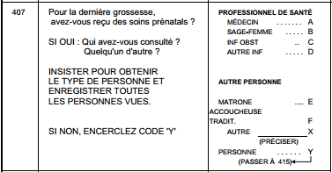

And here is an example of how it was asked in the three most recent surveys:

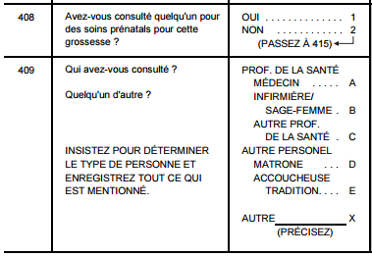

Please note that the categories of sources of ANC vary by country and by survey.

The next relevant question asks if the woman took any medication for the prevention of malaria during her pregnancy. If yes, she is then asked what medication she took. For IPTp coverage we are only interested in the use of SP to prevent malaria so there is a filter which prompts interviewers to continue with questions only for women who reported taking SP. This is followed by a question on the number of times the woman took SP. Following this question there is another filter to verify that the woman reported attending ANC before asking if the SP the woman received was given during an ANC visit. This filter instructs interviewers to go back to the question on source of ANC visit and to continue with the next question only for women who responded with specific responses. As you can see in the examples that follow, the filter specified that women who reported receiving ANC from a doctor, nurse, midwife, or other category of health professional (response codes A, B or C) should be asked the follow-up question on the source of SP, but that those who received ANC only from other providers should not be asked the follow-up question.

Here is an example of the filter:

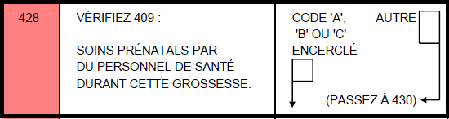

It is this filter that has affected the IPTp estimates from the five surveys discussed here. Restricting the question about the source of SP to women who received ANC from health care professionals was intended to produce more accurate results for IPTp coverage as only providers who were qualified to provide IPTp services would be included. Over time, as funding and training for IPTp programs has increased, the types of providers offering IPTp services have also expanded. The use of the filter in the questionnaire in the five surveys highlighted here had the unintended effect of underestimating the proportion of women receiving SP from ANC providers who were valid sources of IPTp. In the case of the two Guinea surveys, the filter inadvertently left out the ANC provider category corresponding to nurses. In the Mali, ‘matrones’ are a major source of ANC, however this category was excluded from the filter in both the 2006 and the 2012-13 surveys. Although it is unclear if ‘matrones’ would have been legitimate sources of IPTp in the 2006 survey, by 2012-13, “matrones” were definitely being trained to provide IPTp. As seen in the survey-specific questionnaires that follow, ‘matrones’ were not listed as ‘health professionals’ but were listed as ‘other providers’ and were omitted from the filter. The end result was that women who sought ANC from nurses in Guinea and from ‘matrones’ in Mali and who received SP during an ANC visit were not asked the source of the SP they received and were therefore not included in the numerator of the IPTp indicator. In Burkina Faso, it is ‘accoucheuses auxilliaires’ who are a major source of ANC and who were excluded from the filter. The end result was the same as in the other examples: IPTp coverage was likely underestimated.

As the question on source of SP was not asked of a women who received ANC from these sources (‘nurses’ in Guinea, ‘matrones’ in Mali and ‘accoucheuses auxilliaires’ in Burkina Faso), it is not possible to calculate the standard IPTp indicators from the available data; however, with some assumptions it is possible to get a reasonable estimate. For women who received ANC from the sources included in the filter and who reported receiving SP to prevent malaria, data are available on whether or not they received the SP from the ANC visit. For women who received ANC from ‘matrones/accouchesuses auxilliaires’ the assumption was made that women who reported receiving SP obtained the SP from this ANC visit. This assumption may lead to minor overestimation of the true coverage.

The following formulae were used to calculate revised estimates of IPTp coverage for these five surveys. Specifics on the categories of ANC sources (A, B, and C) for each survey can be found in the questionnaires which are summarized immediately following the equations.

Calculations:

|  |  |  |  |
| --- | --- | --- | --- |
| **IPTp1+ =** | Took SP to prevent malaria during most recent pregnancy ending in live birth **AND** took at least one dose **AND** sought ANC from one of the sources included in the filter (A, B or C) **AND** received the SP from an ANC visit | **OR** | Took SP to prevent malaria during most recent pregnancy ending in live birth **AND** took at least one dose **AND** sought ANC from ‘matrone’ or ‘acchoucheuse auxilliaire’ |
| Interviewed women with a live birth in the two years preceding interview | | |

|  |  |  |  |
| --- | --- | --- | --- |
| **IPTp2+ =** | Took SP to prevent malaria during most recent pregnancy ending in live birth **AND** took at least 2 doses **AND** sought ANC from one of the sources included in the filter (A, B or C) **AND** received the SP from an ANC visit | **OR** | Took SP to prevent malaria during most recent pregnancy ending in live birth **AND** took at least 2 doses **AND** sought ANC from ‘matrone’ or ‘acchoucheuse auxilliaire’ |
| Interviewed women with a live birth in the two years preceding interview | | |

|  |  |  |  |
| --- | --- | --- | --- |
| **IPTp3+ =** | Took SP to prevent malaria during most recent pregnancy ending in live birth **AND** took at least 3 doses **AND** sought ANC from one of the sources included in the filter (A, B or C) **AND** received the SP from an ANC visit | **OR** | Took SP to prevent malaria during most recent pregnancy ending in live birth **AND** took at least 3 doses **AND** sought ANC from ‘matrone’ or ‘acchoucheuse auxilliaire’ |
| Interviewed women with a live birth in the two years preceding interview | | |

**The relevant questions from each survey are included here for reference:**

|  |  |
| --- | --- |
| **Burkina Faso 2010 DHS** | |
|  | |
| **Guinea 2005 DHS** | **Guinea 2012 DHS** |
|  |  |

|  |  |
| --- | --- |
| **Mali 2006 DHS** | **Mali 2012/13 DHS** |
|  |  |

This section contains the original tables from each survey’s final report as well as the new numbers from recalculated estimates of IPTp1+ and IPTp2+ coverage. The original estimates are outlined in black, the new estimates in red.

**Burkina Faso DHS 2010 - Original**

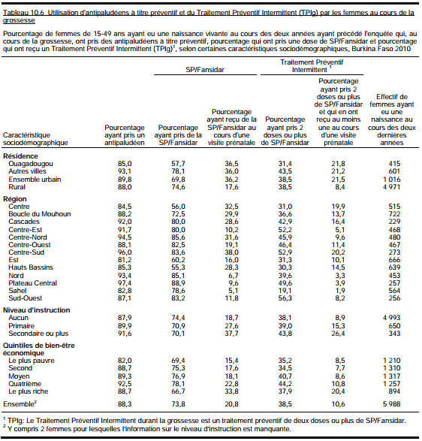

**Burkina Faso DHS 2010 - New**

|  |  |  |  |
| --- | --- | --- | --- |
| Caractéristique | Pourcentage ayant reçu de la SP/Fansidar au cours d'une visite prénatale | Pourcentage ayant pris 2 doses + de SP/Fansidar au cours d'une visite prénatale | Effectif de femmes ayant eu une naissance au cours des deux dernières années |
| **Résidence** |  |  |  |
| Urbain | 62,5 | 37,6 | 1,016 |
| Rural | 72,8 | 38,3 | 4,971 |
|  |  |  |  |
| **Région** |  |  |  |
| Boucle de mouhoun | 66,7 | 36,3 | 722 |
| Cascades | 76,7 | 42,5 | 229 |
| Centre | 49,1 | 30,1 | 515 |
| Centre-est | 79,9 | 52,1 | 468 |
| Centre-nord | 83,3 | 45,6 | 480 |
| Centre-ouest | 80,6 | 45,9 | 467 |
| Centre-sud | 82,7 | 52,2 | 273 |
| Est | 59,8 | 31 | 666 |
| Hauts basins | 49,8 | 29,4 | 639 |
| Nord | 82,5 | 39,1 | 453 |
| Plateau central | 88,6 | 49,4 | 257 |
| Sahel | 77,9 | 19,1 | 564 |
| Sud-ouest | 83 | 56,3 | 256 |
|  |  |  |  |
| **Niveau d'instruction** |  |  |  |
| Aucun | 72,1 | 37,7 | 4,993 |
| Primaire | 68 | 38,5 | 650 |
| Secondaire ou plus | 62,2 | 43,8 | 343 |
|  |  |  |  |
| **Quintile du bien-être économique** |  |  |  |
| Le plus pauvre | 68,3 | 35,1 | 1,210 |
| Second | 73,3 | 34,2 | 1,310 |
| Moyen | 74,9 | 40,3 | 1,317 |
| Quatrième | 75,8 | 43,8 | 1,257 |
| Le plus riche | 59,3 | 37 | 894 |
|  |  |  |  |
| **Ensemble** | 71,1 | 38,2 | 5,988 |

**Guinea DHS 2005 – Original (left) and New (right)**

|  |  |  |  |  |  |  |  |  |  |  |  |  |  |  |  |  |  |  |  |  |  |  |  |  |  |  |  |  |  |  |  |  |  |  |  |  |  |  |  |  |  |  |  |  |  |  |  |  |  |  |  |  |  |  |  |  |  |  |  |  |  |  |  |  |  |  |  |  |  |  |  |  |  |  |  |  |  |  |  |  |  |  |  |  |  |  |  |  |  |  |  |  |  |  |  |  |  |  |  |  |  |  |  |  |  |  |
| --- | --- | --- | --- | --- | --- | --- | --- | --- | --- | --- | --- | --- | --- | --- | --- | --- | --- | --- | --- | --- | --- | --- | --- | --- | --- | --- | --- | --- | --- | --- | --- | --- | --- | --- | --- | --- | --- | --- | --- | --- | --- | --- | --- | --- | --- | --- | --- | --- | --- | --- | --- | --- | --- | --- | --- | --- | --- | --- | --- | --- | --- | --- | --- | --- | --- | --- | --- | --- | --- | --- | --- | --- | --- | --- | --- | --- | --- | --- | --- | --- | --- | --- | --- | --- | --- | --- | --- | --- | --- | --- | --- | --- | --- | --- | --- | --- | --- | --- | --- | --- | --- | --- | --- | --- | --- | --- |
|  | |  |  |  | | --- | --- | --- | | Caractéristique | Pourcentage ayant pris 2 doses + de SP/Fansidar au cours d'une visite prénatale | Effectif de femmes ayant eu une naissance au cours des cinq dernières années | | **Résidence** |  |  | | Urbain | 8,5 | 1,075 | | Rural | 2,1 | 3,372 | |  |  |  | | **Région** |  |  | | Boké | 2 | 506 | | Conakry | 12,8 | 494 | | Faranah | 2,3 | 387 | | Kankan | 0,8 | 631 | | Kindia | 8,1 | 648 | | Labé | 2,6 | 444 | | Mamou | 1,6 | 308 | | N'Zérékoré | 0,4 | 1,028 | |  |  |  | | Région naturelle |  |  | | Conakry | 12,8 | 494 | | Basse Guinée | 5,9 | 1,017 | | Moyenne Guinée | 2,1 | 890 | | Haute Guinée | 0,6 | 857 | | Guinée Forestiere | 1,1 | 1,190 | |  |  |  | | **Niveau d'instruction** |  |  | | Aucun | 3,2 | 3,804 | | Primaire | 4,1 | 400 | | Secondaire ou plus | 9,8 | 243 | |  |  |  | | **Quintile du bien-être économique** |  |  | | Le plus pauvre | 1 | 1,038 | | Second | 2,5 | 933 | | Moyen | 2,3 | 925 | | Quatrième | 2,5 | 831 | | Le plus riche | 11,7 | 720 | |  |  |  | | **Ensemble** | 3,6 | 4,447 | |

**Guinea DHS 2012 – Original (left) and New (right)**

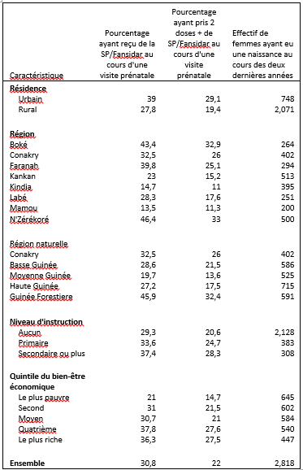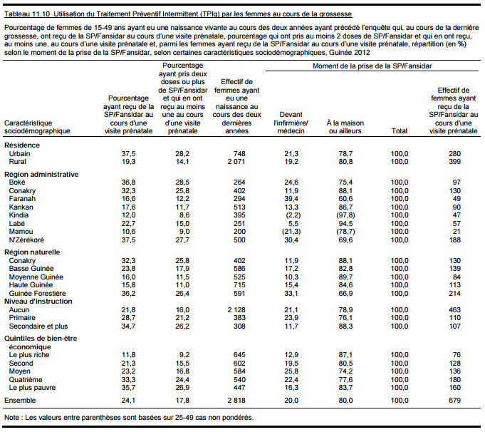

**Mali 2006 DHS - Original**

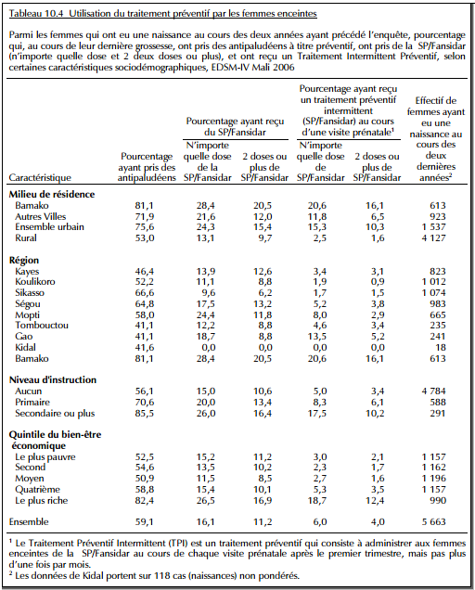

**Mali 2006 DHS - New**

|  |  |  |  |
| --- | --- | --- | --- |
|  | Pourcentage ayant reçu un traitement préventif intermittent (SP/Fansidar) au cours d'une visite prénatale | | Effectif de femmes ayant eu une naissance au cours des deux dernières années |
| Caractéristique | N'importe quelle dose de SP/Fansidar | 2 doses ou plus de SP/Fansidar |
| **Milieu de résidence** |  |  |  |
| Ensemble urbain | 20,4 | 13,1 | 1537 |
| Rural | 11,8 | 8,7 | 4127 |
|  |  |  |  |
| **Région** |  |  |  |
| Kayes | 12,2 | 10,9 | 823 |
| Koulikoro | 9,7 | 7,7 | 1012 |
| Sikasso | 8,3 | 5,3 | 1074 |
| Ségou | 15,8 | 12,2 | 983 |
| Mopti | 22,8 | 10,7 | 665 |
| Tombouctou | 11,2 | 8,2 | 235 |
| Gao | 17,3 | 7,9 | 241 |
| Kidal | 0 | 0 | 18 |
| Bamako | 22,4 | 17,6 | 613 |
|  |  |  |  |
| **Niveau d'instruction** |  |  |  |
| Aucun | 13,4 | 9,4 | 4784 |
| Primaire | 17,2 | 12,3 | 588 |
| Secondaire ou plus | 20,4 | 12,9 | 291 |
|  |  |  |  |
| **Quintile du bien-être économique** |  |  |  |
| Le plus pauvre | 14,1 | 10,5 | 1157 |
| Second | 11,9 | 8,9 | 1162 |
| Moyen | 10,2 | 7,5 | 1196 |
| Quatrième | 13,7 | 8,9 | 1157 |
| Le plus riche | 22 | 14,6 | 990 |
|  |  |  |  |
| **Ensemble** | 14,1 | 9,9 | 5663 |

**Mali 2012/13 DHS – Original (left) and New (right)**

|  |  |  |  |  |  |  |  |  |  |  |  |  |  |  |  |  |  |  |  |  |  |  |  |  |  |  |  |  |  |  |  |  |  |  |  |  |  |  |  |  |  |  |  |  |  |  |  |  |  |  |  |  |  |  |  |  |  |  |  |  |  |  |  |  |  |  |  |  |  |  |  |  |  |  |  |  |  |  |  |  |  |  |  |  |  |  |  |  |  |  |  |  |  |  |  |  |  |  |  |  |  |  |  |  |  |
| --- | --- | --- | --- | --- | --- | --- | --- | --- | --- | --- | --- | --- | --- | --- | --- | --- | --- | --- | --- | --- | --- | --- | --- | --- | --- | --- | --- | --- | --- | --- | --- | --- | --- | --- | --- | --- | --- | --- | --- | --- | --- | --- | --- | --- | --- | --- | --- | --- | --- | --- | --- | --- | --- | --- | --- | --- | --- | --- | --- | --- | --- | --- | --- | --- | --- | --- | --- | --- | --- | --- | --- | --- | --- | --- | --- | --- | --- | --- | --- | --- | --- | --- | --- | --- | --- | --- | --- | --- | --- | --- | --- | --- | --- | --- | --- | --- | --- | --- | --- | --- | --- | --- | --- | --- | --- |
|  | |  |  |  |  | | --- | --- | --- | --- | | Caractéristique | Pourcentage ayant reçu de la SP/Fansidar au cours d'une visite prénatale | Pourcentage ayant pris 2 doses + de SP/Fansidar au cours d'une visite prénatale | Effectif de femmes ayant eu une naissance au cours des deux dernières années | | **Résidence** |  |  |  | | Ensemble urbain | 63.3 | 41 | 805 | | Rural | 45.2 | 25.4 | 3,160 | |  |  |  |  | | **Région** |  |  |  | | Kayes | 49.2 | 30.1 | 498 | | Koulikoro | 49.3 | 26.2 | 828 | | Sikasso | 51.8 | 33.3 | 969 | | Ségou | 46.2 | 24.3 | 731 | | Mopti | 36.7 | 19.4 | 506 | | Bamako | 59.5 | 38.4 | 432 | |  |  |  |  | | **Niveau d'instruction** |  |  |  | | Aucun | 46.3 | 26.9 | 3,235 | | Primaire | 57.1 | 33.7 | 360 | | Secondaire ou plus | 62.7 | 37.5 | 370 | |  |  |  |  | | **Quintile du bien-être économique** |  |  |  | | Le plus pauvre | 34.7 | 19.8 | 809 | | Second | 38.7 | 19.6 | 802 | | Moyen | 45.9 | 26.3 | 771 | | Quatrième | 59.7 | 33.8 | 876 | | Le plus riche | 66.2 | 44.6 | 706 | |  |  |  |  | | **Ensemble** | 48.8 | 28.5 | 3,965 | |