Malaria Indicator Survey

Interviewer’s Manual

ICF
Rockville, Maryland

September 2020

The DHS Program is a five-year project to assist institutions in collecting and analyzing data needed to plan, monitor, and evaluate population, health, and nutrition programs. The DHS Program is funded by the U.S. Agency for International Development (USAID). The project is implemented by ICF in Rockville, Maryland USA, in partnership with the Johns Hopkins Bloomberg School of Public Health/Center for Communication Programs, PATH (formerly, the Program for Appropriate Technology in Health), Avenir Health, Vysnova Partners, Blue Raster, and EnCompass.
The main objectives of The DHS Program are to: 1) provide improved information through appropriate data collection, analysis, and evaluation; 2) improve coordination and partnerships in data collection at the international and country levels; 3) increase host-country institutionalization of data collection capacity; 4) improve data collection and analysis tools and methodologies; and 5) improve the dissemination and utilization of data.
Information about The DHS Program may be obtained from ICF, 530 Gaither Road, Suite 500, Rockville, MD 20850, USA; Telephone: +1.301-407-6500, Fax: +1.301-407-6501, E-mail: info@dhsprogram.com, Internet: http://www.dhsprogram.com.
Recommended citation:
ICF. 2020. Malaria Indicator Survey Interviewer’s Manual. Rockville, Maryland, U.S.A.: ICF

TABLE OF CONTENTS
Malaria Indicator Survey 1
Interviewer’s Manual 1
I. INTRODUCTION 1
A. Survey Objectives 2
B. MIS Sample 2
C. Survey Organization 3
D. Survey Questionnaires 3
E. Fieldworkers’ Roles and Responsibilities 4
F. Training of Interviewers 6
G. Supervision of Interviewers 6
H. MIS Regulations 7
I. Sexual Harassment 8
II. CONDUCTING AN INTERVIEW 9
A. Building Rapport with the Respondent 9
1. Make a good first impression. 9
2. Obtain respondent’s consent to be interviewed. 9
3. Always have a positive approach. 9
4. Assure confidentiality of responses. 9
5. Answer any questions from the respondent frankly. 10
6. Interview the respondent alone. 10
B. Tips for Conducting the Interview 10
1. Be neutral throughout the interview. 10
2. Never suggest answers to the respondent. 11
3. Do not change the wording or sequence of questions. 11
4. Handle hesitant respondents tactfully. 11
5. Do not form expectations. 11
6. Do not hurry the interview. 12
C. Language of the Interview 12
III. FIELDWORK PROCEDURES 13
A. Preparatory Activities and Assignments 13
1. Interviewer’s assignments 13
2. Making callbacks 13
3. Keeping information in the questionnaires confidential 13
4. Supplies and documents needed for fieldwork 14
B. Contacting Households and Eligible Respondents 14
1. Locating sample households 14
2. Problems in contacting a household 15
3. Identifying eligible respondents 16
4. Problems in obtaining individual interviews 16
C. Checking Completed Questionnaires 17
D. Returning Work Assignments 17
E. Data Quality 17
F. Social Media Policy 17
IV. GENERAL PROCEDURES FOR COMPLETING THE QUESTIONNAIRE 20
A. Asking Questions 20
B. Recording Responses 21
C. Correcting Mistakes 23
D. Following Instructions 23
E. Using Display Booklets or Show Cards 24
V. HOUSEHOLD QUESTIONNAIRE 25
A. Identification of the Household 25
B. Completing the Household Questionnaire 25
C. Return to Cover Page 42
VI. WOMAN’S QUESTIONNAIRE 47
A. Cover Page 47
B. Section 1: Respondent’s Background 47
C. Section 2: Reproduction 54
D. Section 3: Pregnancy and Intermittent Preventive Treatment 60
E. Section 4: Fever in Children 62
F. Interviewer’s Observations 64

I. INTRODUCTION
The [YEAR AND COUNTRY] Malaria Indicator Survey (MIS) is a national sample survey designed to provide information on malaria prevention, treatment, and prevalence in [COUNTRY]. The MIS will involve interviewing respondents from randomly selected households, and within selected households, women who are between age [15 and 49] years. Respondents will be asked questions about their background, the children they have given birth to, dwelling conditions, their use of mosquito nets and antimalarial medications for themselves and their children, and other information that will be helpful to policy makers and program planners in controlling malaria.

You are being trained as an interviewer for the MIS. After the training course, which will take about [three] weeks to complete, selected interviewers will be working in teams and going to different parts of the country to interview households and women in these households. This is called fieldwork. Depending on the areas assigned to your team and on how well you perform the tasks given to you, you may be working on the [YEAR AND COUNTRY] MIS for up to [NUMBER OF MONTHS]. However, we have recruited more interviewers to participate in the training course than are needed to do the work, and at the end of the course, we will be selecting the best qualified among you to work as interviewers. Those not selected may be retained as alternates or other survey staff.

During the training course, you will listen to lectures about how to fill in the questionnaires correctly. You will also conduct practice interviews with other trainees and with strangers. You will be given periodic assignments, quizzes, and tests, and you will be observed conducting interviews to check that you read the questions and record the answers accurately.

You should study this manual carefully and learn its contents since this will reduce the amount of time needed for training and will improve your chances of being selected as an interviewer.

Note to users of the Interviewer’s Manual

An assumption has been made throughout this manual that the [YEAR AND COUNTRY] MIS will be a CAPI (computer-assisted personal interviewing) survey. Although paper Household, Woman’s, and Biomarker Questionnaires have been prepared for the [YEAR AND COUNTRY] MIS, only the paper Biomarker Questionnaire will be used in the field. The paper Household and Woman’s Questionnaires you will receive during this training will be used to explain questionnaire content including question text, probes, and coding categories.

While it is critical that you understand certain concepts that are necessary to ensure the correct flow of the questionnaire such as filters and skip patterns, each instance that they occur in the paper questionnaire will be listed in the manual but their purpose will generally not be described because they will be performed automatically by the CAPI data entry program rather than manually by you. Similarly, you will only receive limited instruction on the proper procedures for completing a paper questionnaire (for example, how to correct a coding error). Instead, in a separate part of the training, you will receive instructions on the procedures used for completing a questionnaire through CAPI.

A. Survey Objectives

The [COUNTRY] MIS is part of a worldwide survey program. The Demographic and Health Survey (DHS) Program is one organization that conducts MIS. The international Demographic and Health Surveys (DHS) Program is designed to:

• Assist countries in conducting household sample surveys to periodically monitor and evaluate the national malaria control program.

• Provide an international database that can be used by researchers investigating topics related to malaria.

The MIS is designed to:

- Collect information on various aspects of malaria;
- Measure geographic and socioeconomic differences in malaria indicators;
- Collect a blood drop from young children for anemia and malaria parasitemia testing;

As part of the international DHS Program, surveys are being carried out in malaria endemic countries worldwide. Data from these surveys are used to better understand the malaria situation in the countries surveyed.

B. MIS Sample

There are several ways to gather information about people. One way is to contact every person or nearly every person in the country and ask them questions about what you need to know. Talking to everyone is called a complete enumeration, and a national census is a good example of this type of information gathering. This is very costly because it takes a lot of people to contact everyone. However, in cases such as a national census, it is necessary to have a complete enumeration despite the cost.

Another way to collect information is through a sample survey. When it is not necessary to know exact total numbers, a sample survey can collect information about people much more quickly and at a much lower cost. The sampling procedure allows us to collect data on a small number of people and draw conclusions that are valid for the whole country and subnational areas.

The accuracy of a sample survey depends, among other things, on the size of the sample. The exact number to be interviewed for any survey is determined by statistical methods which we will not discuss in this training session. What you should know, however, is that the sample size for this survey reflects the number of interviews that are needed to provide an accurate picture of the malaria situation in [COUNTRY]. Consequently, it is critical to a survey that fieldworkers try their hardest to complete all assigned interviews to ensure that the correct number of people are included in the survey.

The accuracy of a sample survey also depends on another major factor, the absence of bias that would affect the values estimated from the sample. One of the ways used to avoid bias in the results is to ensure that the selection of people included in the sample is absolutely random. This means that every person in the total population to be studied has the same opportunity (or a known probability) of being selected in the sample. This is why it is so important to make callbacks to reach those people who are not at home, since they may be different from people who are at home at the time of the survey. For example, it may be that healthy children are more likely to be away from the house, and if we don’t call back to test them, we may bias the malaria prevalence estimates.

For the [COUNTRY] MIS, the sample consists of [NUMBER] clusters (small geographically defined areas) spread throughout the country. The households in each of these clusters have recently been listed or enumerated. A sample of households was then scientifically selected to be included in the [COUNTRY] MIS survey from the listing in each of the clusters. Each of these households will be visited and information will be obtained about the household using the Household Questionnaire. Women within those households age 15-49 years will be interviewed using the individual Woman’s Questionnaire. We expect to interview about [NUMBER] households and [NUMBER] women in this survey.

C. Survey Organization

The [COUNTRY] MIS is being conducted at the request of the [SPONSORING ORGANIZATION] which has a primary role in planning for the survey and in the analysis and dissemination of the survey results.

The [IMPLEMENTING AGENCY (IA)] will serve as the implementing agency for the [COUNTRY] MIS. The [IA] will take responsibility for operational matters including planning and conducting fieldwork, processing of collected data, and organizing the writing and distribution of reports. The [IA] will furnish the necessary central office space for survey personnel and will secure transport for the data collection activities. Each team will have a dedicated vehicle during fieldwork. Staff from the [IA] will be responsible for overseeing the day-to-day technical operations including recruitment and training of field and data processing staff and the supervision of the office and field operations.

Financial support for the [COUNTRY] MIS will be provided by [GOVERNMENT OF COUNTRY], USAID, and [OTHER DONORS]. Staff of [ORGANIZATION PROVIDING TECHNICAL ASSISTANCE] will provide technical assistance during all phases of the survey.

During the [COUNTRY] MIS fieldwork, you will work in a team consisting of [NUMBER] female interviewers, [NUMBER] male interviewers, and a supervisor. Each team will be accompanied by a driver. Each supervisor will be responsible for a team of interviewers. The specific duties of the supervisor are described in detail in the Supervisor’s Manual.

In addition, the team will include [NUMBER] [biomarker technicians]. These individuals will be responsible for drawing blood from eligible persons for anemia and malaria testing. The supervisor will have also received an overview of biomarker procedures so that they may supervise the biomarker technicians and assist them as needed.

In the central office there will be a team of national and regional coordinators responsible for supervising fieldwork teams. These coordinators will ensure regular progress of data collection in the clusters. They will monitor data quality, resupply field teams, [and provide for the regular transfer of slides to the central office or a designated laboratory]. Computer programmers also will be assigned to the project.

D. Survey Questionnaires

The households that have been scientifically selected to be included in the [COUNTRY] MIS sample will be visited and enumerated using a Household Questionnaire. The Household Questionnaire includes a cover page to identify the household and a form on which all usual members of the household and visitors are listed. This form is used to record some information about each household member and visitor, such as name, sex, and age. The Household Questionnaire also collects information on housing characteristics, such as type of water source, type of sanitation facility, type of cookstove, the quality of flooring, ownership of durable goods, and ownership and use of mosquito nets.

The Household Questionnaire permits the interviewer to identify women who are eligible to be interviewed with the Woman’s Questionnaire. Women age 15-49 years who are members of the household (those that usually live in the household) or visitors (those who do not usually live in the household but who stayed there the previous night) are eligible to be interviewed.

The Household Questionnaire also permits the interviewer to identify children who are eligible for anemia and malaria testing. Children age 6 months – 4 years are eligible for anemia and malaria testing. Test results are recorded in the Biomarker Questionnaire.

After all of the eligible women in a household have been identified, you will use the individual Woman’s Questionnaire to interview the women you are assigned. The Woman’s Questionnaire collects information on the following topics, among others:

• Background characteristics
• Reproduction
• Intermittent preventive treatment of malaria during pregnancy (IPTp)
• Treatment of fever in children

The Biomarker Questionnaire will be completed by the biomarker technician; it collects information on the following topics:

• Anemia: Children age 6 months to 4 years are eligible to have their blood tested to determine the hemoglobin level. The results of the test are given to the parent or responsible adult for each child. Depending on the hemoglobin level, children may be diagnosed with anemia (mild, moderate, or severe). Children with severe anemia will be referred for treatment, and the parent/responsible adult of children tested for anemia will be provided with information about the causes and prevention of anemia.

• Malaria: Children age 6 months to 4 years are eligible to have their blood tested for malaria parasitemia using a rapid diagnostic test (RDT) [and drops of blood will also be collected on slides to be sent to a laboratory for more sophisticated malaria testing]. The RDT results will be given to the parent or responsible adult for each child. If a child tests positive for malaria with the RDT, the parent/responsible adult of the child will be offered a first-line antimalarial treatment, unless that child is already taking an artemisinin-based combination therapy or has severe malaria (has both anemia and malaria, or has symptoms of severe malaria); children with severe malaria will be referred to a health facility for treatment.

E. Fieldworkers’ Roles and Responsibilities

The interviewer occupies the central position in the MIS because he/she collects information from respondents. Therefore, the success of the MIS depends on the quality of each interviewer’s work.

In general, the responsibilities of an interviewer include the following:

• Locating the structures and households in the sample and completing the Household Questionnaire

• Identifying all eligible respondents in those households

• Interviewing all eligible respondents in the households using the Woman’s Questionnaire

• Checking completed interviews to be sure that all the required questions were asked, and the responses recorded correctly

• Returning to households to interview respondents who could not be interviewed during the initial visit

• Completing the relevant sections of the Biomarker Questionnaire, handing the questionnaire over to a biomarker technician, and receiving the completed Biomarker Questionnaire from the biomarker technician.

These tasks will be described in detail throughout this manual.

The team supervisor is the senior member of the field team. She/he is responsible for the well-being and safety of team members, as well as the completion of the assigned workload and the maintenance of data quality. The supervisor receives her/his assignments from and reports to the [implementing agency coordinator]. The specific responsibilities of the supervisor are to:

• Make the necessary preparations for the fieldwork

• Organize and direct the fieldwork

• Conduct periodic spot-check re-interviews

• Ensure field staff complete their responsibilities

• Ensure all data collection tasks are completed daily and at the close of each cluster.

In addition, the team supervisor will monitor interviewer performance with the aim of improving and maintaining the quality of the data collected. Because the collection of high-quality data is crucial to the success of the survey, it is important that supervisors are mature, responsible women/men who execute their duties with care and precision. This is especially important during the initial phases of fieldwork, when it is possible to eliminate interviewer errors before they become habits.

The biomarker technician occupies an important position in the MIS because she/he collects information from respondents. Therefore, the success of the MIS depends on the quality of the biomarker technician’s work. This work includes:

• Receive the prepared Biomarker Questionnaire from the household interviewer and check that children’s names, ages, and dates of birth have been filled out

• Obtain informed consent, according to the survey protocol, before collecting biomarkers

• Collect biomarker specimens for:
- Malaria using rapid diagnostic tests (RDTs)
- [Malaria using thick [and thin] smears]
- Anemia using the HemoCue 201+

• [Prepare the thick [and thin] smears for transport to the reference laboratory according to the protocol, including fixing the thin smears;]

• Give treatment to positive malaria RDT cases as per the survey protocol

• Refer severe malaria and anemia cases to health care facilities

• Complete the Biomarker Questionnaire and return it to the [household interviewer or team supervisor] for entry into CAPI

• Ensure that the biomarker supplies are well-stocked and appropriately stored

• Follow bio-safety standard operating procedures per the protocol, including the safe disposal of biohazardous material.

The biomarker technicians will receive training on these responsibilities and procedures separately from the interviewer training[; there will be joint sessions to review how interviewers and biomarker technicians work together].

F. Training of Interviewers

Although some people are more adept at interviewing than others, one can become a good interviewer through experience. Your training will consist of a combination of classroom training and practical experience. Before each training session, you should study this manual carefully along with the questionnaire, writing down any questions you have. Ask questions at any time to avoid mistakes during actual interviews. Interviewers can learn a lot from each other by asking questions and talking about situations encountered in practice and actual interviews.

Each of you will receive a package with the following materials.

• Household Questionnaire
• Woman’s Questionnaire
• Biomarker Questionnaire
• Interviewer’s Manual
• CAPI Manual

Please ensure that you bring these materials each day during the training. The manuals and copies of the Biomarker Questionnaire should be brought to the field during fieldwork.

During the training, the questionnaire sections, questions, and instructions will be discussed in detail. You will see and hear demonstration interviews conducted in front of the class as examples of the interviewing process. You will practice reading the questionnaire aloud to another person several times so that you become comfortable with reading the questions aloud. You will also be asked to take part in role playing in which you practice by interviewing another trainee.

The training will include field practice interviewing in which you will actually interview household respondents and eligible women. You will be required to check and correct the questionnaires just as you would do in the actual fieldwork assignments.

You will be given assignments, quizzes, and tests to see how well you are progressing during your formal training period. At the end of the training course, the interviewers will be selected based on their test results and performance during the field practice.

The training you receive as an interviewer does not end when the formal training period is completed. Each time a supervisor meets with you to discuss your work, your training is being continued. This is particularly important during the first few days of fieldwork. As you run into situations you did not cover in training, it will be helpful to discuss them with your team. Other interviewers may be running into similar problems, so you can all benefit from each other’s experiences.

G. Supervision of Interviewers

Training is a continuous process. Observation and supervision throughout the fieldwork are a part of the training and data collection process. Your team supervisor will play a very important role in continuing your training and in ensuring the quality of the [COUNTRY] MIS data. Your supervisor will:

• Spot-check some of the addresses selected for interviewing to be sure that you interviewed the correct households and the correct respondents;

• Review each questionnaire to be sure it is complete and consistent;

• Observe some of your interviews to ensure that you are asking the questions in the right manner and recording the answers correctly;

• Meet with you on a daily basis to discuss performance and give out future work assignments;

• Help you resolve any problems that you might have with finding the assigned households, understanding the questionnaire, or dealing with difficult respondents.

H. MIS Regulations

The survey director may terminate the service of any interviewer who is not performing at the level necessary to produce the high-quality data required to make the [COUNTRY] MIS a success.

For the workload to be equally divided and the support equally shared, the following survey regulations have been established and will be strictly enforced:

1. Except for illnesses, any person who is absent from duty during any part of the training or any part of the fieldwork (whether it is a whole day or part of a day) without prior approval from his/her supervisor may be dismissed from the survey.

2. The selection of the survey team members is competitive; it is based on performance, ability, and testing results during the training. Therefore, any person found offering assistance to or receiving assistance from another person during tests will be dismissed from the survey.

3. Throughout the survey training and the fieldwork period, you are representing [IA], an organization of the Government of [COUNTRY]. Your conduct must be professional and your behavior must be congenial in dealing with the public. We must always be aware that we are only able to do our work with the goodwill and cooperation of the people we interview. Therefore, any team member who is consistently overly aggressive, abrupt, or disrespectful to the people in the field may be dismissed from the survey team.

4. For the survey to succeed, each team must work closely together, sharing in the difficulties and cooperating and supporting each other. We will attempt to make team assignments in a way that enhances the cooperation and goodwill of the team. However, any team member who in the judgment of the survey director creates a disruptive influence on the team may be asked to transfer to another team or may be dismissed from the survey.

5. It is critical that the data gathered during the fieldwork be both accurate and valid. To control for inaccurate or invalid data, spot checks will be conducted. Interviewers may be dismissed at any time during the fieldwork if their performance is not considered adequate for the high quality this survey demands.

6. Vehicles and gasoline are provided for the survey for official use only. Any person using the vehicle for an unauthorized personal reason will be dismissed from the survey.

7. [COUNTRY] MIS data are confidential. They should not be discussed with anyone other than members of your survey team. Under no circumstances should confidential information be passed on to third parties. In keeping with this policy, it is also important that you never interview anyone you may know in the survey. Persons breaking these rules, and therefore the confidence placed in them, will be dismissed.

I. Sexual Harassment

Sexual harassment will not be tolerated during the process of conducting the [COUNTRY] MIS survey. By sexual harassment, we mean unwelcome sexual advances, requests for sexual favors, and other sexual comments or actions that make the receiver feel offended or intimidated. Sexual harassment may hurt work performance, and in some cases, an individual may feel that they must comply with the unwelcome advances or requests in order to keep their job. Sexual harassment can be committed by a man toward a woman, by a woman toward a man, or between two individuals of the same gender.

To avoid any appearance of sexual harassment, individuals should be careful to avoid unnecessary physical contact and suggestive language and should maintain a professional work climate at all times.

Anyone who feels that he or she has been the target of sexual harassment or who has witnessed an apparent incident of harassment should immediately report the incident to his or her supervisor, or to the survey coordinator from the [implementing agency]. The [implementing agency] is required to investigate the claim and keep reports confidential to the extent possible. The [implementing agency] must take actions to prevent and correct harassing behavior. These actions can include changing workspace, reassigning interviewers or supervisors to different teams, and other disciplinary actions. Retaliation against individuals filing complaints of sexual harassment will also trigger disciplinary action.

II. CONDUCTING AN INTERVIEW
Successful interviewing is an art and should not be treated as a mechanical process. Each interview is a new source of information, so make it interesting and pleasant. The art of interviewing develops with practice but there are certain basic principles that are followed by every successful interviewer. In this section you will find a number of general guidelines on how to build rapport with a respondent and conduct a successful interview.

A. Building Rapport with the Respondent

The supervisor will assign an interviewer to make the first contact with each of the households selected for the [COUNTRY] MIS. Any capable member of the household age 15 years or older is a suitable respondent for the household interview. If at least one eligible woman is identified in the Household Questionnaire, the interviewer will go on to complete a Woman’s Questionnaire.

As an interviewer, your first responsibility is to establish good rapport with a respondent. At the beginning of an interview, you and the respondent are strangers to each other. The respondent’s first impression of you will influence their willingness to cooperate with the survey. Be sure that your manner is friendly as you introduce yourself. Before you start to work in an area, your supervisor will have informed the local leaders that you will be in the area. You will also be given a letter and an identification badge that states that you are working with [IA].

1. Make a good first impression.

When you arrive at the household, do your best to make the respondent feel at ease. With a few well-chosen words, you can put the respondent in the right frame of mind for the interview. Open the interview with a smile and greeting such as “good afternoon” and then proceed with your introduction.

2. Obtain respondent’s consent to be interviewed.

You must obtain a respondent’s informed consent for participation in the survey before you begin an interview. Special consent statements are included at the beginning of the Household Questionnaire and the Woman’s Questionnaire. The statements explain the purpose of the survey. They assure a respondent that participation in the survey is completely voluntary and that it is their right to refuse to answer any questions or stop the interview at any point. Be sure to read the informed consent statement exactly as it is written before asking a respondent to participate in a household or individual interview.

3. Always have a positive approach.

Do not adopt an apologetic manner, do not use words such as “Are you too busy?” Such questions invite refusal before you start.

4. Assure confidentiality of responses.

If the respondent is hesitant about responding to the interview or asks what the data will be used for, explain that the information you collect will remain confidential, no individual names will be used for any purpose, and all information will be grouped together to write a report.

Also, you should never mention other interviews or show completed questionnaires to the supervisor in front of a respondent or any other person.

5. Answer any questions from the respondent frankly.

Before agreeing to be interviewed, the respondent may ask you some questions about the survey or how he or she was selected to be interviewed. Be direct and pleasant when you answer.

The respondent may also be concerned about the length of the interview. If the respondent for the Household Questionnaire asks how long the interview will take, tell the respondent that the interview usually takes about 15 minutes. If the respondent to the woman’s Questionnaire asks, tell her that the interview usually takes about 10-20 minutes. Indicate your willingness to return at another time if it is inconvenient for the respondent to answer questions then.

Respondents may ask questions or want to talk further about the topics you bring up during the interview, e.g., about specific malaria treatments. It is important not to interrupt the flow of the interview so tell them that you will be happy to answer their questions or to talk further after the interview.

6. Interview the respondent alone.

The presence of a third person during an interview can prevent you from getting frank, honest answers from a respondent. It is, therefore, very important that the individual interview be conducted privately and that all questions be answered by the respondent.

If other people are present, explain to the respondent that some of the questions are private and ask to interview the person in the best place for talking alone. Sometimes asking for privacy will make others more curious, so they will want to listen; you will have to be creative. Establishing privacy from the beginning will allow the respondent to be more attentive to your questions.

If it is impossible to get privacy, you may have to carry out the interview with the other people present. However, in such circumstances, it is important that you remember that:

• If there is more than one eligible respondent in the household, you must not interview one in the presence of the other;

• Extra effort should be made to gain privacy if the other person is of the opposite sex, particularly the husband or wife.

In all cases where other individuals are present, try to separate yourself and the respondent from the others as much as possible. You can also sit very near the respondent and lower your voice when asking the questions so that others who are nearby cannot hear the questions.

B. Tips for Conducting the Interview

1. Be neutral throughout the interview.

Most people are polite and will tend to give answers that they think you want to hear. It is therefore very important that you remain absolutely neutral as you ask the questions. Never, either by the expression on your face or by the tone of your voice, allow the respondent to think that he/she has given the “right” or “wrong” answer to the question. Never appear to approve or disapprove of any of the respondent’s replies.

If the respondent gives an ambiguous answer, try to probe in a neutral way, asking questions such as the following:

“Can you explain a little more?”
“I did not quite hear you; could you please tell me again?”
“There is no hurry. Take a moment to think about it.”

2. Never suggest answers to the respondent.

If a respondent’s answer is not relevant to a question, do not prompt him/her by saying something like “I suppose you mean that. . . Is that right?” In many cases, he/she will agree with your interpretation of his/her answer, even when that is not what he/she meant. Rather, you should probe in such a manner that the respondent himself/herself comes up with the relevant answer. You should never read out the list of coded answers to the respondent, even if he/she has trouble answering.

3. Do not change the wording or sequence of questions.

The wording of the questions and their sequence in the questionnaire must be maintained. If the respondent has not understood the question, you should repeat the question slowly and clearly. If there is still a problem, you may reword the question, being careful not to alter the meaning of the original question. Provide only the minimum information required to get an appropriate response.

4. Handle hesitant respondents tactfully.

There will be situations where the respondent simply says, “I don’t know,” gives an irrelevant answer, acts very bored or detached, or contradicts something they have already said. In these cases, you must try to re-interest them in the conversation. For example, if you sense that they are shy or afraid, try to remove their shyness or fear before asking the next question. Spend a few moments talking about things unrelated to the interview (for example, their town or village, the weather, their daily activities, etc.).

If the respondent is giving irrelevant or elaborate answers, do not stop them abruptly or rudely, but listen to what they have to say. Then try to steer them gently back to the original question. A good atmosphere must be maintained throughout the interview. The best atmosphere for an interview is one in which the respondent sees the interviewer as a friendly, sympathetic, and responsive person who does not intimidate them and to whom they can say anything without feeling shy or embarrassed. As indicated earlier, a major problem in gaining the respondent’s confidence may be one of privacy. This problem can be prevented if you are able to obtain a private area in which to conduct the interview.

If the respondent is reluctant or unwilling to answer a question, explain once again that the same question is being asked of women or households all over [COUNTRY] and that the answers will all be merged together. If the respondent is still reluctant, in CAPI, you will write REFUSED as a comment to the question; further instructions on how to handle refusals in CAPI will be discussed during the CAPI portion of this training. In a paper questionnaire, write REFUSED next to the question and proceed as if nothing had happened. Remember, the respondent cannot be forced to give an answer.

5. Do not form expectations.

You must not form expectations of the ability and knowledge of the respondent. For example, do not assume women and men from rural areas or those who are less educated or illiterate do not know about using mosquito nets or different kinds of antimalarial medications.

However, remember that differences between you and the respondent can influence the interview. The respondent, believing that you are different from her/him, may be afraid or mistrustful. You should always behave and speak in such a way that she/he is put at ease and is comfortable talking to you.

Respondents may ask for things such as mosquito nets; never promise anything that you cannot provide as they may leave a negative impression of surveys with the respondent.

6. Do not hurry the interview.

Ask the questions slowly to ensure the respondent understands what is being asked. After you have asked a question, pause and give the respondent time to think. If the respondent feels hurried or is not allowed to formulate their own opinion, they may respond with “I don’t know” or give an inaccurate answer. If you feel the respondent is answering without thinking just to speed up the interview, say to the respondent, “There is no hurry. Your opinion is very important, so consider your answers carefully.”

C. Language of the Interview

The questionnaires for the [COUNTRY] MIS have been translated into [COUNTRY LANGUAGE(S) IN WHICH INTERVIEWING WILL TAKE PLACE]. One of the first things you will do when you approach a household to do an interview is to establish the language or languages that are spoken there. We will be arranging the field teams in such a way that you will be working in an area in which your language is spoken, so there should be few cases in which respondents do not speak your language. In such cases you might be able to find another language that both of you speak and you will be able to conduct the interview in that language.

However, in some cases, it will not be possible for you to find a language which both you and the respondent speak. In this case, try to find out if the respondent speaks a language which another member of your team or the team supervisor speaks. If so, tell your supervisor so that he or she can arrange for that person to conduct the interview.

If at all possible, try to avoid using interpreters since this not only jeopardizes the quality of the interview but also will mean that the interview will take more time to conduct. However, if the respondent does not speak a language which any of your team members speak, you will need to rely on a third person to translate for you. Since the interview involves some sensitive topics, it is best if you can find another woman to act as an interpreter if you are conducting the woman’s interview. You should not use the respondent's husband as an interpreter under any circumstances. Children are also not suitable interpreters.

We will be practicing interviews in the local languages during training. However, there may be times when you will have to modify the wording of the questions to fit local dialects and culture. It is very important not to change the meaning of the question when you rephrase it or interpret it into another language.

III. FIELDWORK PROCEDURES
Fieldwork for the [COUNTRY] MIS will proceed according to a timetable, and the survey will be successful only if each member of the interviewing team understands and follows correct field procedures. The following sections review these procedures and describe the proper procedures for receiving work assignments and keeping records of selected households.

A. Preparatory Activities and Assignments

1. Interviewer’s assignments

Each morning, your supervisor will brief you on your day’s work and explain how to locate the households assigned to you. The supervisor will use the CAPI system to assign households to you, and a list of assigned households will appear on your tablet computer. The process by which you receive assignments will be described in detail during the CAPI portion of this training. The information you will receive includes the household number, structure number, address, and name of the head of the household.

When you receive your work assignment, review it and ask any questions you might have. Remember that your supervisor will not always be available to answer questions when the work begins. You should be sure that:

• You know the location of the selected households you are to interview, and have sufficient materials (maps, written directions, etc.) to find them;

• You understand any special instructions from your supervisor about contacting the households you are assigned;

• You have several blank Biomarker Questionnaires.

After completing a household interview, the final result code of the household interview will be indicated on your list of assigned households.

2. Making callbacks

Because each household has been carefully selected, you must make every effort to conduct interviews with the individuals who are identified as eligible in that household. Sometimes a household member eligible for interview will not be available at the time you first visit. You need to make at least 3 visits on three separate times of the day or days when trying to obtain an individual interview to maximize the possibility of successfully completing the individual interview.

At the beginning of each day, you should examine your notes to see if you made any appointments for revisiting a household or eligible respondent. If no appointments were made, make your callbacks to a respondent at a different time of day than the earlier visits; for example, if the initial visits were made in the early afternoon, you should try to arrange your schedule so you make a call back in the morning or late afternoon. Scheduling callbacks at different times is important in reducing the rate of non-response (i.e., the number of cases in which you fail to contact a household or complete an individual interview).

3. Keeping information in the questionnaires confidential

You are responsible for seeing that the information in the questionnaires is kept confidential. Do not share the results with other interviewers. You should never interview a household in which you know one or more of the members, even if they are only casual acquaintances. If you are assigned to a household in which you know a person even if that person is not eligible for interview, you should notify your supervisor so he/she can assign that household to another interviewer. You should not attempt to see the completed questionnaires for that household nor discuss the interview results with your colleagues.

4. Supplies and documents needed for fieldwork

Before starting fieldwork each morning, verify that you have everything you need for the day’s work. Some necessary supplies include:

• A fully charged tablet computer
• [A sufficient number of Biomarker Questionnaires]
• Interviewer’s Manual
• Identification badge
• Blue ink pens
- [A display book with pictures of mosquito nets, malaria medications, etc. and/or samples of these items]
• A bag to carry your tablet computer and other materials

B. Contacting Households and Eligible Respondents

1. Locating sample households

In recent months, household listing teams visited each of the selected sample clusters to:

1) prepare up-to-date maps to indicate the location of structures;
2) record address information for each structure or describe their location (for areas lacking street names or numbers on structures);
3) write numbers on structures; and
4) make a list of the names of the heads of households in all the structures.

A structure is a free-standing building for residential use, commercial use, or a combination of residential and commercial use. A structure may contain one or more rooms in which people live; examples include a villa house, a detached house, an apartment building, a gated house (urban area), or a compound (rural area). In the case where one household lives in a compound of several huts, all of the huts are considered to be a single structure, whether or not they are fenced.

Within a structure, there may be one or more dwelling (or housing) units. A dwelling unit is a room or group of rooms occupied by one or more households. It may be distinguished from the next dwelling unit by a separate entrance. For instance, there would be one dwelling unit in a thatched hut, but there may be 50 dwelling units in an apartment building or 5 dwelling units in a compound.

Within a dwelling unit, there may be one or more households. By definition, a household consists of a person or group of persons, related or unrelated, who live together in the same dwelling unit, who acknowledge one adult male or female as the head of household, who share the same living arrangements, and are considered as one unit. In some cases, one may find a group of people living together in the same house, but each person has separate eating arrangements; they should be counted as separate one-person households. Collective living arrangements such as hostels, army camps, boarding schools, or prisons are not considered as households in the MIS.

Specific households have been selected to be interviewed, and you should not have any trouble in locating the households assigned to you if you use the structure number and the name of the head of the household to guide you. The structure number is usually written above the door of the house, but sometimes it may be on the wall. Although the supervisor of your team will be with you in the field, it is important that you also know how to locate the structures in the sample by using the sketch map.

2. Problems in contacting a household

In some cases, you will have problems locating the households that were selected because the people may have moved or the listing teams may have made an error. Here are examples of some problems you may find and how to solve them:

a) The household has moved away and a new one is now living in the same dwelling. In this case, interview the new household.

b) The structure number and the name of the household head do not match with what you find in the field. If you have located the correct dwelling, you should consider the household that is living in the dwelling as the selected household.

Example: You are assigned a household headed by Thomas Smith that is listed as living in structure number MIS-004. But when you go to MIS-004, the household living there is headed by Michael Jones. After checking that you have not made a mistake about the structure or dwelling unit, you would interview the household headed by Michael Jones.

c) The household selected does not live in the structure that was listed. If there is a discrepancy between the structure number and the name of the household head, interview whoever is living in the structure assigned to you.

Example: You are assigned a household headed by Robert Stevens located in MIS-007, and you find that the Stevens household actually lives in structure MIS-028. Interview the household living in MIS-007.

d) The listing shows only one household in the dwelling, but two or three households are living there now. When the listing shows only one household and you find two or three households, interview all of them. To interview the second and third households, you will use a menu option in the CAPI system called “Interview a household not in the original sample.”

If the listing shows two households, only one of which was selected, and you find three households there now, only interview the one that had been selected and ignore the other two.

e) The head of the household has changed. In some cases, the person listed as the household head may have moved away or died since the listing. Interview the household that is living there.

f) The house is all closed up and the neighbors say the people are on the farm (or away visiting, etc.) and will be back in several days or weeks. Enter Code ‘3’ (ENTIRE HOUSEHOLD ABSENT FOR EXTENDED PERIOD). The house should be revisited at least two more times to make sure that the household members have not returned.

g) The house is all closed up and the neighbors say that no one lives there; the household has moved away permanently. Enter Code ‘6’ (DWELLING VACANT OR ADDRESS NOT A DWELLING).

h) A household is supposed to live in a structure that when visited is found to be a shop and no one lives there. Check very carefully to see whether anyone is living there. If not, enter Code ‘6’ (DWELLING VACANT OR ADDRESS NOT A DWELLING).

i) A selected structure is not found in the cluster, and residents tell you it was destroyed in a recent fire or other incident. Enter Code ‘7’ (DWELLING DESTROYED).

j) No one is home and neighbors tell you the family has gone to the market, church, the local health post, etc. Enter Code ‘2’ (NO HOUSEHOLD MEMBER AT HOME OR NO COMPETENT RESPONDENT AT HOME AT TIME OF VISIT) and return to the household at a time when the household members will be back.

Discuss with your supervisor any problems you have in locating the households that you are assigned to interview. Remember that the usefulness of the MIS sample in representing the entire country depends on the interviewers locating and visiting all the households they are assigned.

3. Identifying eligible respondents

To be “eligible” means to “qualify” for something. An eligible respondent is someone who is qualified to be included in our survey. You will use the Household Questionnaire to identify who is eligible to be interviewed with the Woman’s Questionnaire.

All women age 15-49 in selected households who are either usual members of the household or visitors who stayed in the household the night before the day you are conducting the interview are considered eligible in the [COUNTRY] MIS. It is very important that you do not miss an eligible respondent when you fill in the Household Schedule.

In certain cases, you may find it difficult to decide whether or not a respondent is eligible. Use these examples as a guide:

Example(s): A visitor who spent the previous night in the house but is away at the market when you arrive is eligible. You must make callbacks to interview her.

A woman is a usual resident, but she spent the previous night away at her sister’s house. She should be counted as a usual member of the household on the Household Schedule and is eligible to be interviewed.

A young woman is away at the university and only returns for very short visits. She is not a usual resident of the household.

A Woman’s Questionnaire must be completed for each eligible respondent that you identify in the household.

In some households, there will be no eligible women (i.e., there will be no female usual household members or visitors of eligible age). For these households, you will have a completed Household Questionnaire only.

4. Problems in obtaining individual interviews

You may experience the following types of problems in obtaining an interview with an eligible respondent:

a) Eligible respondent not available. If the eligible respondent is not at home when you visit, enter Code ‘2’ (NOT AT HOME) as the result for the visit and ask a neighbor or household member when the respondent will return. You should contact the household at least three times, trying to make each visit at a different time of day. Under no circumstances is it acceptable to conduct all three visits on the same day and then stop attempting to contact the respondent.

b) Respondent refuses to be interviewed. The respondent’s availability and willingness to be interviewed will depend in large part on the initial impression you make when you meet them. Introduce yourself and explain the purpose of the visit. Read the introduction printed on the Woman’s Questionnaire. You may emphasize the confidentiality of the information the respondent provides, and/or the short duration of the interview. If the respondent is unwilling to be interviewed, it may be that the present time is inconvenient. Ask whether another time would be more convenient and make an appointment. If the individual still refuses to be interviewed, enter Code ‘4’ (REFUSED) as the result for the visit and report it to your supervisor.

c) Interview not completed. A respondent may be called away during the interview or may not want to answer all the questions at the time you visit them. If an interview is incomplete for any reason, you should arrange an appointment to see the respondent again as soon as possible to obtain the missing information. Be sure that the interview is categorized in the CAPI system as Code ‘5’ (PARTLY COMPLETED). You should also report the problem to your supervisor.

d) Respondent incapacitated. There may be cases in which you cannot interview a person because they are too sick, because they are mentally unable to understand your questions, or because they are deaf, etc. In these cases, record Code ‘6’ (INCAPACITATED).

C. Checking Completed Questionnaires

It is the responsibility of the interviewer to review each questionnaire when the interview is finished. This review should be done before you leave the household so that you can be sure that every appropriate question was asked and that all answers are clear and reasonable. If you identify a keying error that affects the skip instructions, you may need to talk further with the respondent. Simply explain to the respondent that you made an error and ask the question(s) again.

Anything out of the ordinary that occurred during the interview should be explained in the comments section at the end of the questionnaire. These comments are very helpful to the supervisor in checking questionnaires. Comments are also read in the office and used to resolve problems encountered during secondary editing.

D. Returning Work Assignments

At the end of the day, you will send the questionnaires you have completed to the team supervisor. The procedures for doing so will be presented in the CAPI portion of the training. Be prepared to tell your supervisor about any problems you experienced in locating a household or completing a Household Questionnaire or in conducting an interview with an eligible respondent. For difficult cases, at least three visits will be made to a household during the MIS in an effort to obtain a completed interview.

E. Data Quality

It is the responsibility of the supervisor to review both the Household Questionnaires and the Woman’s Questionnaires from a sample cluster while the interviewing team is still in the cluster. The types of checks the supervisor will perform will be discussed in the CAPI portion of the training. The supervisor will discuss with each interviewer the errors found in the collection of data. It may sometimes be necessary to send an interviewer back to a respondent in order to correct some errors.

F. Social Media Policy

The use of social media and other digital media is now common and continues to grow in popularity. Platforms and applications, including blogs, social networking sites (such as Twitter or Facebook), video streaming sites (such as YouTube), and digital messaging applications (WhatsApp), have made it easy for anyone to reach a wide audience very quickly. Public and private companies and their staff also use these platforms and sites to share work experiences, images, or videos taken in the workplace, or to seek professional advice from colleagues or friends. However, in the [COUNTRY] MIS, the use of social media may break the promise we make to our respondents to maintain their privacy and keep all information confidential. The [COUNTRY] MIS has also made a promise to the ICF Institutional Review Board and the [COUNTRY] Institutional Review Board to maintain anonymity of all survey respondents.

To fulfill our promise to all survey respondents to maintain strict confidentiality, all fieldworkers are obligated to follow these rules:

Social media rules for maintaining confidentiality of survey respondents
1. | Survey staff have an ethical obligation to maintain respondent privacy and confidentiality at all times.
2. | Limiting access to social media postings by using privacy settings is not enough to ensure privacy or maintain the confidentiality of respondents.
3. | Do not transmit any respondent-related image or video that includes the respondent, respondent household members, or their homes, through any social media platform.
4. | Do not identify respondents, enumeration areas, or clusters by name through any social media platform. Do not post any information that may lead to the identification of a respondent or an enumeration area.
5. | Do not take any photos or videos of respondents or their homes – not even if the respondent gives permission – on personal mobile devices - including mobile phones, tablets, and cameras.
6. | Turn off or disable geolocation or geotagging permissions in social media applications on personal mobile devices while conducting fieldwork.
7. | Consult with a supervisor before making any work-related postings.
8. | Promptly report any violations of privacy or confidentiality.

What is geolocation and geotagging?

Geolocation or geotagging refers to identifying an object (for example a photo) by its location. Many social media platforms, including Twitter and Facebook, now include geolocation or geotagging, so users can add location information to their messages. The location information can be a broad location such as a city or village, or a precise location with the exact latitude and longitude of the location from which a message was sent. A fieldworker who posts a geolocated or geotagged social media message from the field violates confidentiality by disclosing the location of the cluster.

Geolocation or geotagging in social media applications may also have security implications. In security-risk countries, where fieldwork must undergo stringent protocols to protect field teams, it is imperative that survey-related staff disable geolocation from their personal devices so as to not give away secure locations.

Common Misunderstandings of Social Media

Misuse of social media is often unintentional and the result of misunderstandings of how social media platforms function. A number of factors may contribute to survey-related staff inadvertently violating survey respondent privacy and confidentiality while using social media.

Test your knowledge. TRUE or FALSE?

Q 1. A communication or post is private and can only be seen by the intended recipient. True or False?

FALSE. Why? Once you send or post something, it can be sent by someone else to others, without you knowing.

Q 2. You can always delete posted content and make it “go away”. True or False?

FALSE. Why? What happens on the Internet, stays on the Internet.

IV. GENERAL PROCEDURES FOR COMPLETING THE QUESTIONNAIRE
To collect the information needed by the [COUNTRY] MIS, you must understand how to ask each question, what information the question is attempting to collect, and how to handle problems that might arise during the interview. You must also know how to correctly record the answers the respondent gives and how to follow special instructions in the questionnaire. This part of the training manual is designed to familiarize you with the [COUNTRY] MIS paper questionnaire that you are using for training. However, a number of the concepts presented also apply to tablet computer-based interviewing but are done automatically by the CAPI program.

A. Asking Questions

It is very important that you ask each question exactly as it is written in the questionnaire. When you are asking a question, speak slowly and clearly so that the respondent will have no difficulty hearing or understanding the question. At times you may need to repeat the question to be sure the respondent understands it. In those cases, do not change the wording of the question but repeat it exactly as it is written.

If, after you have repeated a question, the respondent still does not understand it, you may have to restate the question. Be very careful when you change the wording, however, that you do not alter the meaning of the original question.

In some cases, you may have to ask additional questions to obtain a complete answer from a respondent (we call this ‘probing’). If you do this, you must be careful that your probes are “neutral” and that they do not suggest an answer to the respondent. Probing requires both tact and skill, and it will be one of the most challenging aspects of your work as a [COUNTRY] MIS interviewer.

You will notice that some questions contain one or more words in parentheses. As shown below, the presence of parentheses indicates that a sentence needs to be adapted to fit the respondent’s specific situation. In CAPI, most choices/substitutions will be done by the program.

1. Parentheses that indicate a choice must be made:

Example:

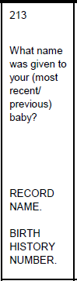
This question is asked to female respondents who have had a child since [2015]. How you phrase the question—that is, which words in parentheses you choose to insert into the sentence—will depend on the birth order of the child. If you are asking the woman about her most recent birth, that is her youngest child, you would ask, “What name was given to your most recent baby?” If you are asking the woman about her second-to-last child, for example, you would ask, “What name was given to your previous baby?”

2. Parentheses that indicate a substitution must be made:

Example:

Notice that the word in parentheses is in all capital letters. As you will learn later (see Section D below), words in all caps are instructions to interviewers that are not meant to be read out loud. Instead, in this example, you should substitute in the name of the individual the question is being asked about. For instance, if you are asking a child named Barack, ask “Has Barack been ill with a fever at any time in the last 2 weeks?”

B. Recording Responses

All interviewers should use pens with blue ink to complete all paper questionnaires. Never use a pencil to complete the survey questionnaire.

There are three types of questions in the [COUNTRY] MIS questionnaire: 1) questions that have precoded responses; 2) questions that do not have precoded responses, i.e., those that are “open-ended;” and 3) filters.

1. Questions with precoded responses

For some questions, we can predict the types of answers a respondent will give. The responses to these questions are listed in the questionnaire. To record a respondent’s answer, you merely circle the number (code) that corresponds to the reply. Make sure that each circle surrounds only a single number.

Example:

In some cases, precoded responses will include ‘OTHER.’ The OTHER code should be selected only when the respondent’s answer is different from any of the precoded responses listed for the question. Before using the OTHER code, you should make sure the answer does not fit in any of the specified categories. When you select the OTHER code for a particular question you must always write the respondent’s answer in the space provided.

Example:
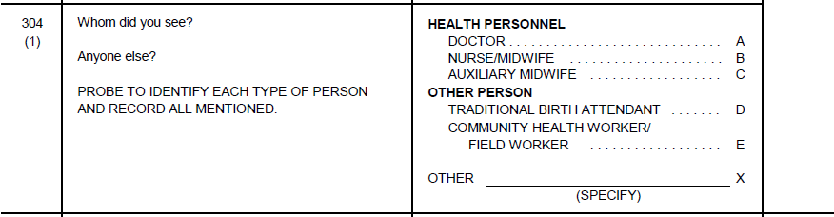
Pharmacist

2. Recording responses that are not precoded

The answers to some questions are not precoded but require that you write the respondent’s answer in the space provided.

Recording numbers or dates in boxes. In some questions, you will record a number or date in the boxes provided. There are two ways this is done:

• Boxes preceded by codes. Whenever the boxes are preceded by codes, you will fill in the boxes in one row only. You must first circle the code that identifies the row you have chosen and then fill in the response in the boxes only for that row.

Example: If the respondent says she is 3 weeks pregnant, circle Code ‘1’ for WEEKS and write the response in the boxes next to the ‘1’.

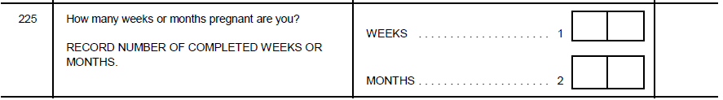
0 3

• Boxes without preceding codes. Whenever boxes are present without codes in front of them, you must enter information in all of the boxes.

Example: For a child born on 2 May 2020, you must record the day, month, and year.
0 2
0 5
2 0 2 0

When a response has fewer digits than the number of boxes provided, you should fill in leading zeroes. For example, a response of ‘5’ is recorded ‘05’ in two boxes, or if three boxes had been provided, you would record ‘005’.

3. Marking filters

Filters require you to look back to the answer to a previous question and then mark an ‘X’ in the appropriate box. (See Section D.2 below for a description of filters.) In CAPI, filters will be automatically completed.

Example:

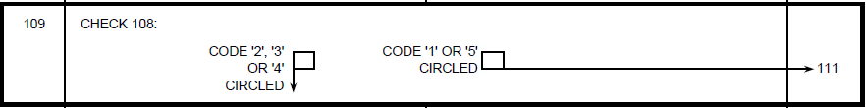

C. Correcting Mistakes

When working with a paper questionnaire, it is very important that you record all answers neatly. For precoded responses, be sure that you circle the code for the correct response carefully. For open-ended responses, the reply should be written legibly so that it can be easily read. If you made a mistake in entering a respondent’s answer or she changes her reply, be sure that you cross out the incorrect response and enter the right answer. Do not erase an answer. Just put two diagonal lines through the incorrect response.

Here is how to correct a mistake:

Example:

Remember that if you are not careful to cross out mistakes neatly, it may not be possible to determine the correct answer when the data are entered later into the computer.

D. Following Instructions

Throughout the [COUNTRY] MIS questionnaire, instructions for the interviewer are written in all CAPITAL LETTERS, whereas questions to be asked of the respondent are printed in small letters. You should pay particular attention to the skip and filter instructions that appear throughout the questionnaire.

1. Skip instructions

It is very important not to ask a respondent any questions that are not relevant to his or her situation. For example, a woman who is not pregnant should not be asked for how many weeks or months she has been pregnant. In cases where a particular response makes subsequent questions irrelevant, an instruction is written in the questionnaire directing you to skip to the next appropriate question. In CAPI, skips occur automatically based on the information you have already entered.

Example: In Q. 224, notice that if you selected Code ‘2’ or Code ‘8’ you would skip to Q. 301. Q. 225 is about how many weeks or months the respondent is pregnant and is only asked of women who responded ‘YES’ to Q. 224.

2. Filters

To ensure the proper flow of a paper questionnaire, you will sometimes be directed to check a respondent’s answer to an earlier question, indicate what the response was by marking a box with an ‘X’, and then follow the relevant skip instruction. Questions of this type are called “filters”; they are used to prevent a respondent from being asked irrelevant, and perhaps embarrassing or upsetting, questions.

The CAPI program will automatically complete the filter based on the information you have already entered.

Example:
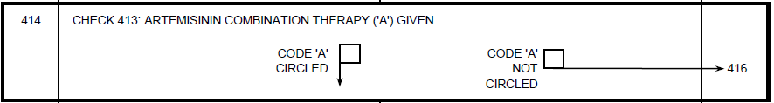

E. Using Display Booklets or Show Cards
[NOTE TO SURVEY MANAGER: IF YOU INTEND TO USE DISPLAY BOOKLETS OR SHOW CARDS, ADD TEXT DESCRIBING THEIR PURPOSE AND HOW TO USE THEM HERE. COMMON ITEMS TO INCLUDE IN A BOOKLET OR SHOW CARD INCLUDE: TEXT FOR THE LITERACY TEST, IMAGES OF MOSQUITO NETS, AND IMAGES OF SP/FANSIDAR, ACTs, AND OTHER COMMON ANTIMALARIALS.]

V. HOUSEHOLD QUESTIONNAIRE
The purpose of the Household Questionnaire is to provide information on general characteristics of the population and their households. You will use it to identify women who are eligible to be interviewed with the Woman’s Questionnaire and children who are eligible for the Biomarker Questionnaire.

A. Identification of the Household

Before you go to a selected household, you will receive the identification information that appears in the box at the top of the cover page from your supervisor. This information includes:

- The name of the place or locality in which you are working.

- The name of the head of the household.

- The cluster number and household number.

The rest of the cover page will be completed after you have conducted the interview.

B. Completing the Household Questionnaire

To complete the Household Questionnaire, you will need to find a suitable respondent. Any adult member of the household age 15 or older who is capable of providing information needed to fill in the Household Questionnaire can serve as the respondent. If an adult is not available, do not interview a young child; instead, go on to the next household, and call back at the first household later.

Generally, you will ask a single individual in the household for the information you will need to complete the Household Questionnaire. However, as appropriate, you may need to consult other members of the household for specific information.

INFORMED CONSENT

After introducing yourself, you must seek the respondent’s consent for participation in the survey. Read the informed consent statement exactly as it is written. This statement explains the purpose of the survey. It assures the respondent that his or her participation in the survey is completely voluntary and that he or she can refuse to answer any questions or stop the interview at any point.

After reading the statement, you must affirm that you have read the statement to the respondent. In a paper questionnaire, you do this by signing in the space provided. In a CAPI survey, you do this by selecting ‘1’ (RESPONDENT AGREES TO BE INTERVIEWED).

If the respondent does not agree to be interviewed, select ‘2,’ thank the respondent, and end the interview. Then select ‘5’ (REFUSED) as the result code for the visit.

Q. 100: TIME

The time of the day you start the household interview will be automatically recorded using the 24-hour system.

HOUSEHOLD SCHEDULE (Qs. 1-9)

Be sure to read the introductory sentence (in Column 2) to inform the respondent that you are interested in getting information about all usual household members and any other persons who stayed in the household the night before the interview.

Column 1: LINE NUMBER

In Column 1, each row of the household schedule is assigned a unique number. This number is referred to as the ‘Line Number.’ It is used to identify the person listed on that row and to link all information collected later in the household and individual interviews to that person. The CAPI system will automatically assign a line number to each person you list in the household schedule. While the paper questionnaire only provides space for 10 persons, the CAPI program will allow you to list up to 50.

Column 2: USUAL RESIDENTS AND VISITORS

The first step in completing the household schedule is to make a list of all persons who usually live in the household and any visitors who stayed in the household the previous night. To get a correct listing, you will have to know what we mean by a member of the household and what we mean by a visitor:

- Member of the household. A household may be one person or a group of persons who usually live and eat together. This is not the same as a family. A family includes only people who are related, but a household includes any people who live together, whether or not they are related. For example, three unrelated men who live and cook meals together would not be considered one family, but they would be considered to be members of the same household.

- Visitor. A visitor is someone who is not a usual member of the household but who stayed in the household the night before the day you are conducting the interview. If an individual stayed in the household the previous night, he or she should be listed on the Household Schedule.

Sometimes, it is not easy to know whom to include in the household and whom to leave out. Here are some examples:

• A woman lists her husband as head of the household, but he lives somewhere else. If he does not usually live in the household you are interviewing, and he did not stay there the previous night, he should not be included in the listing.

• Sometimes, people eat in one household and sleep in another. Consider the person to be a member of the household where he or she sleeps.

• A person living alone is a household.

• A domestic worker is a member of the household if he or she usually lives in the household.

Anyone included in the household listing has to be either a usual resident of that household—Column 5 is YES—or has to have spent the previous night in the household—Column 6 is YES.

As your respondent lists the names, write them down, one in each row in Column 2, beginning with the household head. The person who is identified as the head of the household has to be someone who usually lives in the household. This person may be acknowledged as the head on the basis of age (older), sex (often, but not necessarily, male), economic status (main provider), or some other reason. It is up to the respondent to define who heads the household. There generally should not be a problem with this. If the person responding to the household interview is not the head of household, then you may record this person on the second line.

After entering a name, you will ask the questions in Columns 3 to 7 before going on to record the name of the next person.

Column 3: RELATIONSHIP TO HEAD OF HOUSEHOLD

Record how the person listed is related to the head of the household. Use the codes at the bottom of the page. If the respondent is not the head of the household, make sure that you record the relationship of each person to the household head, not the relationship to the respondent.

Example: if the respondent is the wife of the head of the household and she says that Simon is her brother, then Simon should be coded as Code 09 (OTHER RELATIVE) not Code 08 (BROTHER OR SISTER), because Simon is a brother-in-law of the head of the household.

If the head of the household is married to a woman who has a child from a previous marriage, that child’s relationship to the head of the household should be coded as Code 10 (ADOPTED/FOSTER/STEPCHILD).

Column 4: SEX

Always confirm the sex of a person before recording it in Column 4 since there are many names that may be given to either a male or female.

Columns 5 and 6: RESIDENCE

In Column 5, record information on the person’s usual residence. A usual member of the household may or may not have stayed in the household the night before the interview. However, a visitor must always have stayed in the household the night before the interview to be included in the household schedule.

If after asking these residence questions you learn that the person does not usually live in the household—Column 5 is NO—and did not sleep there the night before—Column 6 is also NO—you will have to delete this person from the listing because he/she is neither a usual member nor a visitor.

Column 7: AGE

If you have difficulty obtaining the ages of household members or visitors, use the methods described for Qs. 102 and 103 in the Woman’s Questionnaire to probe for the correct age. You are to obtain each person’s age in completed years, that is, the age at the time of the last birthday.

When you have completed columns 2-7 for each household member or visitor, you want to be certain you have included everyone who should be listed before continuing with the rest of the questionnaire. To do this, ask questions 2A-2C at the end of the Household Schedule. If the answer to any of these questions is YES, add those persons’ names to the list.

Columns 8 and 9: ELIGIBILITY

The CAPI program will check columns 4 and 7 and automatically identify women age 15-49 in Column 8. These individuals are “eligible” respondents, and they qualify for an interview using the Woman’s Questionnaire. Remember, the respondent may be a usual resident of the household or only a visitor.

The CAPI program will also identify children age 0-5 who may be eligible for anemia and malaria testing in Column 9.

HOUSEHOLD CHARACTERISTICS (Qs. 101-135)

After asking the questions about each member of the household, you will ask Questions 101 through 135 about household amenities and possessions.

Q. 101: HOUSEHOLD DRINKING WATER

The aim of this question is to identify the household’s main source of drinking water. If drinking water is obtained from several sources, probe to determine the source from which the household obtains most of its drinking water. If the source varies by season, record the main source used at the time of the interview.

Q. 102: MAIN SOURCE OF WATER FOR OTHER PURPOSES

Households that use bottled [or SACHET] water as a source of drinking water are asked for the main source of water for cooking and handwashing to identify the source of water to which the household has general access.

The table below provides definitions of the water source response categories in Qs. 101 and 102.

Definitions of Water Source Codes for Qs. 101 and 102
Response Categories | Definition
Piped into dwelling | Pipe connected with in-house plumbing to one or more taps, e.g. in the kitchen and bathroom. Sometimes called a house connection.  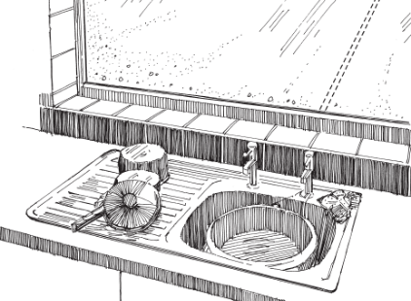
Piped to yard/plot | Pipe connected to a tap outside the house in the yard or plot. Sometimes called a yard connection.  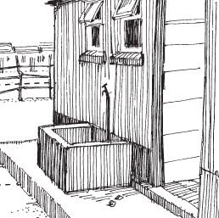
Piped to neighbor | Pipe connected to neighbor’s dwelling, yard, or plot.
Public tap or standpipe | Public water point from which community members may collect water. A standpipe may also be known as a public fountain or public tap. Public standpipes can have one or more taps and are typically made of brickwork, masonry or concrete.  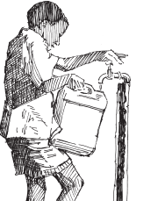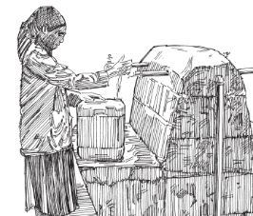  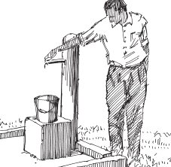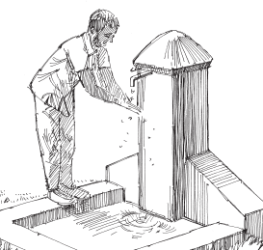
Tube well or borehole | A deep hole that has been driven, bored, or drilled with the purpose of reaching ground water supplies. Water is delivered from a tube well or borehole through a pump which may be human, animal, wind, electric, diesel, or solar-powered.  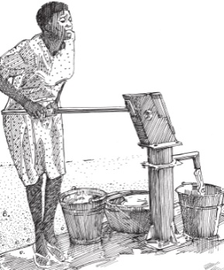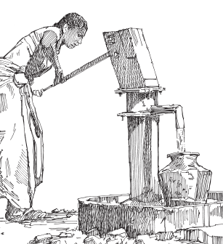
Protected dug well | A dug well that is (1) protected from runoff water through a well lining or casing that is raised above ground level and a platform that diverts spilled water away from the well and (2) covered so that bird droppings and animals cannot fall down the hole. Both conditions must be observed for a dug well to be considered as protected.  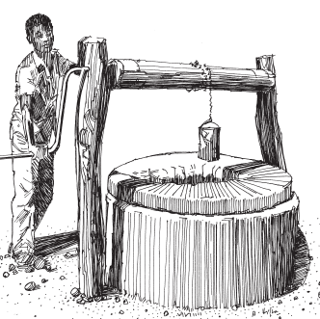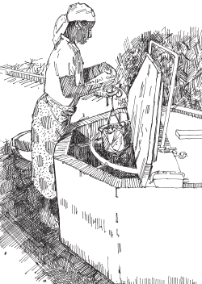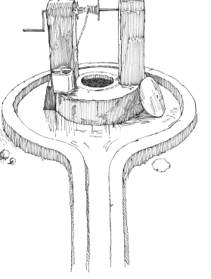
Unprotected dug well | A dug well which is (1) unprotected from runoff water; (2) unprotected from bird droppings and animals; or (3) both.  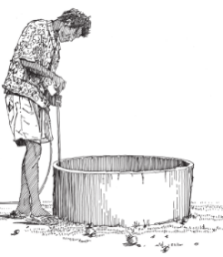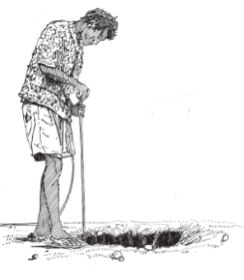
Protected spring | A spring protected from runoff, bird droppings, and animals by a “spring box” which is typically constructed of brick, masonry, or concrete and is built around the spring so that water flows directly out of the box into a pipe without being exposed to outside pollution.  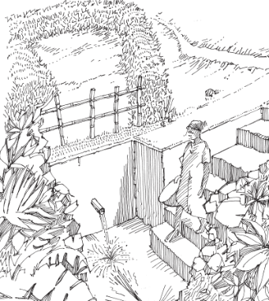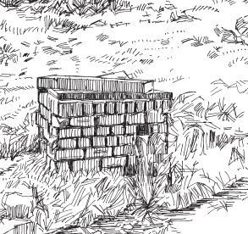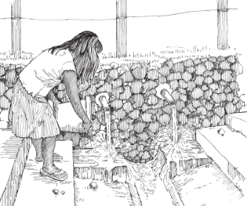
Unprotected spring | A spring that is subject to runoff and/or bird droppings or animals. Unprotected springs typically do not have a “spring box.”
Rainwater | Rain that is collected or harvested from surfaces by roof or ground catchment and stored in a container, tank, or cistern.  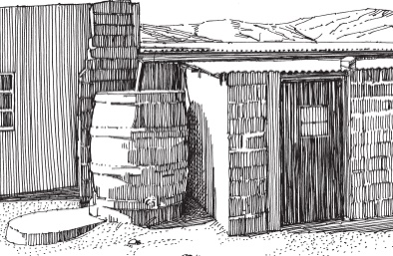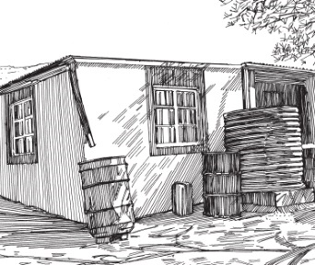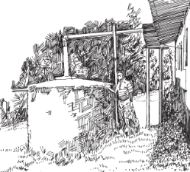
Tanker truck | Water is obtained from a provider who uses a truck to transport water into the community. Typically, the provider sells the water to households.  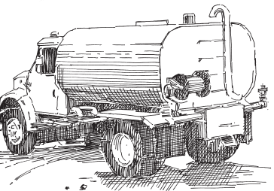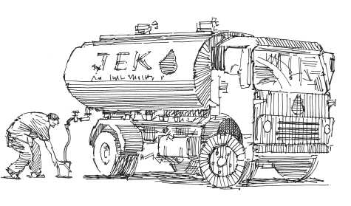
Cart with small tank | Water is obtained from a provider who transports water into a community using a cart and then sells the water. The means for pulling the cart may be motorized or non-motorized (for example, a donkey).  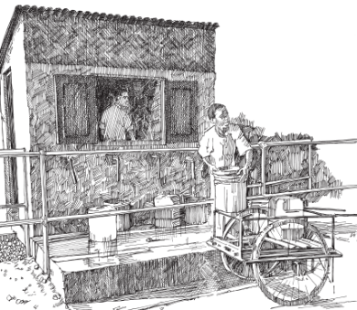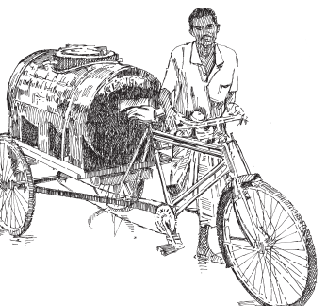
Surface water | Water located above ground, including rivers, dams, lakes, ponds, streams, canals, and irrigation channels.  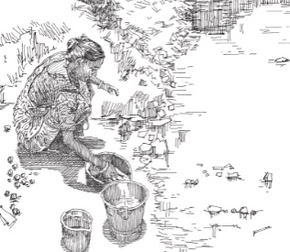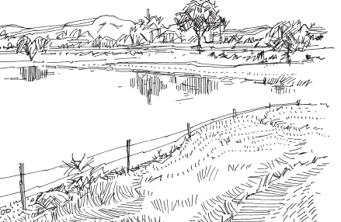
Bottled water | Water that is bottled and sold to the household in bottles. Note that this code is present in Q. 101 but not Q. 102.

Q. 103: LOCATION OF WATER SOURCE

IN OWN DWELLING and IN OWN YARD/PLOT means the water is located in the dwelling or in the yard (such as a well that is in the yard). If the household gets their water from a TANKER TRUCK or CART WITH A SMALL TANK (Code 61 or Code 71 in Q. 101 or Q. 102), you would record ELSEWHERE in Q. 103 (Code 3) because the truck or cart does not reside in the dwelling or yard.

Q. 104: TIME TO GET WATER

This question is not asked if the source of drinking water is located within the dwelling or yard/plot or if the household relies on rainwater.

Include the time it takes to get to the source, wait to get water (if necessary), and get back to the house. Record the time it takes to get water by whatever means of transportation the person generally uses, whether the person walks or rides a bicycle or motor vehicle. If the respondent tells you that the water is delivered to their dwelling (a situation that could arise if the water comes from a tanker truck or a small cart with a tank and the truck or cart delivers right to the dwelling), record ‘000’.

Convert answers given in hours to minutes. Put zeroes in front of the response if necessary; for example, “30 minutes” would be ‘030,’ and “one hour and a half” would be ‘090’.

Q. 105: TOILET FACILITIES

The purpose of this question is to obtain a measure of the sanitation level of the household, since toilet facilities are important for disease control and health improvement. If the respondent answers in general terms such as “flush toilet,” probe to determine where the toilet flushes to; likewise, if the respondent answers “latrine,” probe to determine the type of latrine. The table below provides definitions for the terms used in the codes for Q. 105.

If you are not able to determine the toilet type based on your conversation with the respondent, ask to observe the facility.

Definitions of Toilet Facility Codes in Q. 105
Response Categories | Definition
Flush/pour flush toilet | A flush toilet uses a cistern or holding tank for flushing water and has a water seal, which is a U-shaped pipe, below the seat or squatting pan that prevents the passage of flies and odors.  A pour flush toilet uses a water seal, but unlike a flush toilet, a pour flush toilet uses water poured by hand for flushing (no cistern is used).
- to piped sewer system | A system of sewer pipes (also called sewerage) that is designed to collect human excreta (feces and urine) and wastewater and remove them from the household environment. Sewerage systems consist of facilities for collection, pumping, treating and disposing of human excreta and wastewater.  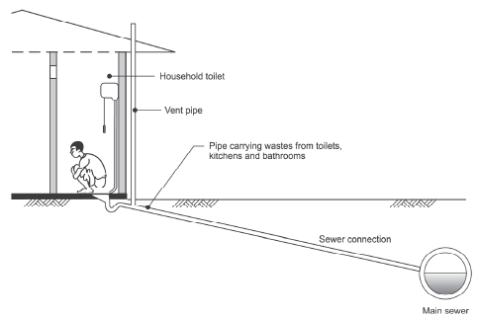
- to septic tank | An excreta collection device consisting of a water-tight settling tank normally located underground, away from the house or toilet.  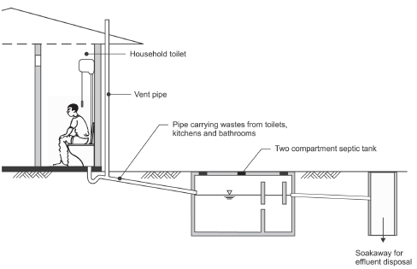
- to pit latrine | A system that flushes excreta to a hole in the ground.
- to somewhere else | A system in which the excreta is deposited in or nearby the household environment in a location other than a sewer, septic tank, or pit, e.g., excreta may be flushed to the street, yard/plot, drainage ditch or other location.
Pit latrine | Excreta are deposited without flushing directly into a hole in the ground.
- ventilated improved pit latrine (VIP) | A dry pit latrine ventilated by a pipe extending above the latrine roof. The open end of the vent pipe is covered with gauze mesh or fly-proof netting.  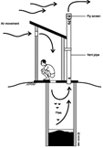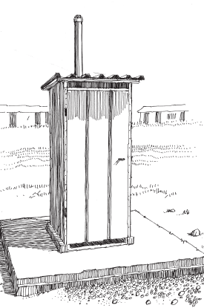  If the vent pipe is not covered by a gauze mesh or fly-proof netting, the facility should be classified as a pit latrine with slab not a VIP latrine. The inside of the VIP latrine is kept dark. If the door of the VIP superstructure is missing so that it is no longer dark inside the latrine, the facility should be classified as a pit latrine with slab, not a VIP latrine.
- pit latrine with slab | A dry pit latrine whereby the pit is fully covered by a slab or platform that is fitted either with a squatting hole or seat. The slab or platform should be solid and can be made of any type of material (such as concrete, logs with earth or mud, or cement). The slab or platform should adequately cover the pit so that pit contents are not exposed other than through the squatting hole or seat.  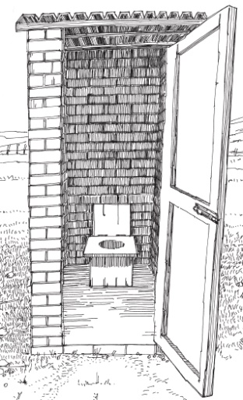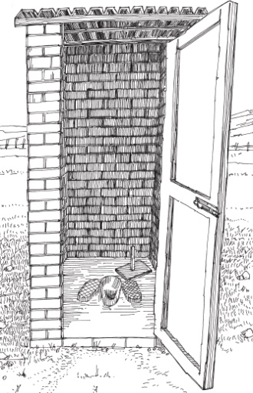
- pit latrine without slab/open pit | A latrine without a squatting slab, platform or seat. An open pit is a rudimentary hole in the ground where excreta is collected.  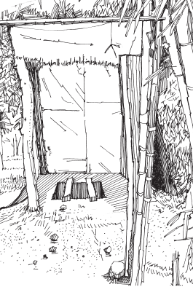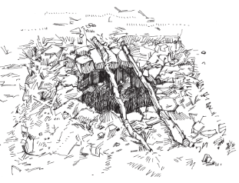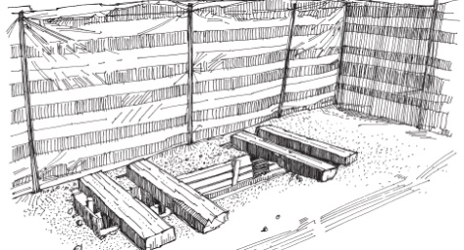
Composting toilet | A dry toilet into which excreta and carbon-rich material are combined (vegetable wastes, straw, grass, sawdust, ash) and special conditions maintained to produce inoffensive compost. A composting latrine may or may not have a urine separation device.  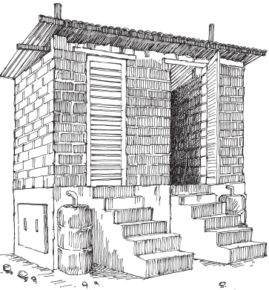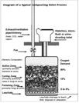
Bucket toilet | The use of a bucket or other container for the retention of feces (and sometimes urine and anal cleaning material), which is periodically removed for treatment, disposal or use as fertilizer.  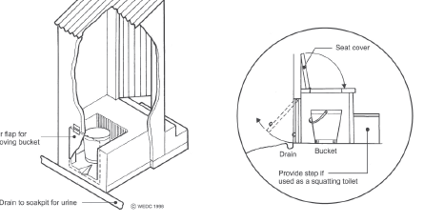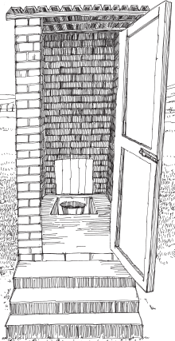
Hanging toilet/  Hanging latrine | A toilet built over the sea, a river, or other body of water allowing excreta to drop directly into the water.  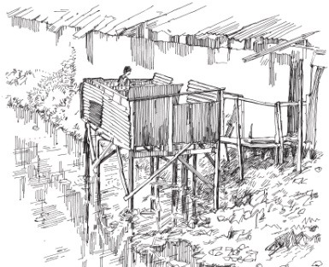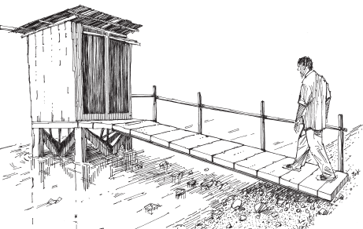

Qs. 106 and 107: SHARED TOILET FACILITIES

Q. 106 asks about whether the toilet facilities are shared with one or more other households. In Q. 107, we want to find out how many households, including the respondent’s household, use the same facility. For example, if the respondent’s household shares the toilet with one other household, record ‘02’ in Q. 107. If they share it with two other households, record ‘03’ in Q. 107. The number of households that share toilet facilities is an important measure of the level of hygiene in the household.

Q. 108: LOCATION OF TOILET FACILITY

IN OWN DWELLING and IN OWN YARD/PLOT means the toilet is located inside the dwelling or the yard/plot. Record ELSEWHERE when the toilet is outside the dwelling or yard/plot.

Q. 109: TYPE OF COOKSTOVE USED FOR COOKING

Q. 109 seeks to determine what type of stove the household uses for cooking at home. Information on the type of cookstove is collected as a measure of the socioeconomic status of the household. Cooking food over open fires or inefficient stoves can expose people to air pollution, which contributes to heart and lung diseases. In contrast, the use of cleaner, more modern cookstoves is associated with positive health outcomes.

If the household uses more than one type of cookstove, record the type they use most often. If the respondent is unsure of the type of cookstove used, ask to observe it. The response code ‘NO FOOD COOKED IN HOUSEHOLD’ should only be selected if no one cooks food in the household.

Q. 110: COOKSTOVE FUEL OR ENERGY SOURCE

The use of some cooking fuels can have adverse health consequences. Remember that this question asks about fuel for a cookstove, not fuel for heating or lighting.

If the household uses more than one fuel with their cookstove, find out the fuel used most often. If any fuel other than the precoded ones is reported as being the main fuel used, select ‘96’ and specify the type of fuel in the space provided.

Q. 111: NUMBER OF ROOMS FOR SLEEPING

Record the number of rooms that the household uses for sleeping even if a room also serves a second function. For example, if a dwelling unit consists of two rooms: a bedroom and a kitchen, but household members sleep in both the bedroom and the kitchen, record ‘2’ in Q. 111.

Qs. 112 and 113: OWNERSHIP OF LIVESTOCK, HERDS, POULTRY, OR OTHER FARM ANIMALS

Information on whether households own any livestock, herds, poultry, or other animals and how many they own is used as an additional indicator of the socioeconomic status of the household. First, ask Q. 112 to find out whether the household owns any livestock, herds, other farm animals, or poultry. If YES, ask Q. 113 to find out what type of animals the household owns and how many of each. Read out each item and be sure to record the number in the respective boxes for each item. Do not leave any blank.

Note: Q. 113 asks separately for the number of milk cows or bulls and cattle the household owns. Be sure not to double-count these animals. For example, if the respondent says that the household has 10 cattle, one of which is a milk cow and one of which is a bull, record two milk cows or bulls and eight cattle since the household owns a total of 10 animals, not 12.

Qs. 114 and 115: OWNERSHIP OF AGRICULTURAL LAND

Ownership of agricultural land is another important indicator of the socioeconomic status of the household. First ask Q. 114 to find out whether any member of the household owns any land that is used for agriculture. Agricultural land refers to land that is used for growing crops (the crops may be food for people, food for animals, or other non-food crops), raising animals, and grazing animals. In answering this question, common land used to graze animals but not owned by the household should not be included. If the answer to Q. 114 is YES, ask Q. 115 on the number of hectares owned altogether by the members of the household. Record the answer in the boxes. If the household owns more than 95 hectares, select ‘950;’ if the number of hectares is unknown, select ‘998’. If the household owns less than 0.1 hectare, record 00.0.

Q. 116: HOUSEHOLD ITEMS

The answers to these questions on ownership of certain items will be used as a proxy measure of the socioeconomic status of the household. Read out each item and select the answer given after each item. Do not leave any item(s) blank.

If the respondent reports that a household item such as a radio is broken, try to find out how long it has been broken and whether it will be fixed. If the item appears to be out of use only temporarily, select ‘1’ for YES. Otherwise, select ‘2’ for NO.

Q. 117: OWNERSHIP OF WATCH/MOBILE PHONE/MEANS OF TRANSPORTATION

This question collects additional information related to socioeconomic status. We ask whether any member of the household owns a watch, a mobile phone, or various means of transport, e.g., a bicycle, a motorcycle or motor scooter, a car or truck, and other means of transportation. A small child’s bicycle is primarily a toy and should not be recorded here.

If the respondent reports that an item is broken, try to find out how long it has been broken and whether it will be fixed. If the item appears to be out of use only temporarily, record ‘1’ for YES. Otherwise, record ‘2’ for NO.

Q. 118: BANK ACCOUNT

The bank account may be held at a bank, credit union, microfinance institution, cooperative, post office, or [country-specific financial institutions]. The account allows the person to deposit and withdraw funds. Do not include savings programs at the community level.

Q. 119: MOBILE FINANCIAL TRANSACTIONS

Mobile phones can be used to conduct financial transactions even if the user does not have a bank account. Make sure to read the entire question to the respondent so they understand the different types of financial transactions that the question refers to. It does not matter with whom or through whom the transaction is made, whether through a bank or through a mobile money transfer system, [such as Mpesa].

Qs. 120 and 121: POSSESSION OF MOSQUITO NETS

It is recognized that the consistent use of insecticide-treated mosquito nets (ITN) decreases the incidence of malaria and malaria-related deaths, especially in very young children. Consequently, many countries have instituted programs that promote the use of ITNs.

Q. 120 asks whether the household has any mosquito nets, and, for households with at least one mosquito net, information is collected in Q. 121 on the total number of mosquito nets in the household. It does not matter if the nets are actually used or even if they are set up. If they are in the household and could be used while sleeping, they should be counted.

Note that ‘cake covers’ or baby nets that are used to keep flies off infants, usually during the daytime, are not considered mosquito nets. These nets are not treated with insecticide. Window screens are also not considered mosquito nets.

Qs. 122-130 are asked for each mosquito net the household has, up to 7 nets in total.

Q. 122: ASSIGNMENT OF NET NUMBER

Each net the household has is assigned a net number. For example, if the household has four nets, the first net you choose to ask questions about will be net number ‘01.’ After you are done asking Qs. 123-130 about net number ‘01,’ the next net will be net number ‘02,’ and you will ask the same Qs. 123-130, but now about net number ‘02.’ You then repeat this process for nets ‘03’ and ‘04.’

Qs. 123-130: OBSERVATION OF NETS, TYPE OF NETS, SOURCE OF NETS, AND USE ON THE NIGHT BEFORE THE INTERVIEW

There are various brands of mosquito nets. Almost all are factory treated and do not require any retreatment (long-lasting insecticide-treated net; LLIN). To assess the effectiveness of mosquito net use in preventing malaria, we need to gather information on how long the household has had each net, the brand of net, and whether household members use the nets when they sleep at night.

To obtain this information, you will need to ask Qs. 123 through 130 as applicable for each net that the household owns.

Q. 123: NET OBSERVED OR NOT

Ask to see the net. Record whether you were able to actually observe the net.

Even if you cannot directly observe a net, you must ask the questions about it. To distinguish each net, you may use phrases like, “Now let’s talk about the first net you showed me” or “Let’s talk about the net hanging in that corner.”

Q. 124: WHEN NET OBTAINED

Next ask how many months ago the household obtained the net. If the net was obtained within 36 months before the interview date, you must record the actual number of months before the interview that the net was obtained. If the household got the net more than 36 months ago, record ‘95’. The respondent may tell you that they are not exactly certain when the net was obtained. In such cases, probe to try to get some idea of approximately how many months ago the net was obtained. Record ‘98’ (NOT SURE) if the respondent does not have any idea of how long ago the household obtained the net.

Q. 125: TYPE AND BRAND OF NET

Q. 125 asks about the type and brand of net. In this survey, there are three ways of categorizing a net:

The net is a long-lasting insecticide-treated net (LLIN): Most nets you will come across in the field are LLINs, and you will become familiar with the most common brands of LLINs during the training; however, you may encounter nets in the field that you will not recognize. If the respondent tells you or you learn from the packaging that the net is an LLIN, but it is not one of the listed brands or if you cannot determine the brand, select code ‘16’ (OTHER/DON’T KNOW BRAND (LLIN)). If you cannot observe the net and the brand is unknown, show pictures of typical net types/brands to the respondent in an effort to identify it.

The net is NOT an LLIN: In some cases, you may confirm that the net is not an LLIN; for those nets, select ‘96’ (OTHER TYPE (NOT LLIN)).

You cannot determine whether the net is an LLIN or not: If you cannot obtain information on whether the net is an LLIN or not, select ‘98’ (DON’T KNOW TYPE).

Qs. 126 and 127: SOURCE OF NET

Qs. 126 and 127 are used to determine the source of each net. In Q. 126, ask if the household got the net through [NAME OF CAMPAIGN], during an antenatal care visit, or during an immunization visit. For a net that was not obtained through a campaign, an antenatal care visit, or during an immunization visit, ask where the household got the net (Q. 127).

Qs. 128 and 129: SLEEPING UNDER THE MOSQUITO NET

These questions help us to link a particular mosquito net to the person(s) who slept under it the night before the survey. Obviously, it does little good to have LLINs in the household if they are not used for sleeping at night. In Q. 128, ask the respondent if anyone slept under the mosquito net last night, and if the respondent answers YES, record in Q. 129 who slept under the net last night. If more than four people slept under a single net the night before the survey, record only the first four people mentioned by the respondent. For each person mentioned, record their name and their corresponding line number from the household schedule.

Q. 130: REASON FOR NOT SLEEPING UNDER NET

If no one slept under the net last night, ask for the main reason it was not used. If the respondent mentions several reasons, record the main reason the net was not used.

Q. 131: FILTER FOR NEXT NET

At this point, go back to Q. 122 for the next net, and ask Qs. 123-130. If you have finished asking Qs 122-130 for all the nets belonging to the household, proceed to Q. 132.

Q. 132: FLOOR MATERIAL

This is an observation not a question since you will usually be able to see for yourself what kind of floor the house has. However, ask if you are not sure.

If there is more than one kind of flooring material, record the main type of material (the material that covers the largest amount of floor space).

Q. 133: ROOF MATERIAL

As with the floor material, you will usually be able to see for yourself what kind of roof material the house has. However, observing the roof material may not always be easy or you may be able to observe part but not the whole roof. Ask the respondent the type of roof material if you are not sure or if you cannot observe the roof properly. If the household lives in an apartment building, look at the roof from a reasonable distance and ask the respondent if necessary. If there is more than one kind of roofing material, record the main type of material (the material that covers the largest amount of roof space).

Q. 134: WALL MATERIAL

As with the floor and roof materials, you will usually be able to see for yourself what kind of material the exterior walls are made of. However, ask the respondent if you are not sure. Again, if there is more than one kind of wall material, record the main type of material (the material that covers the largest amount of exterior wall space).

Q. 135: TIME INTERVIEW ENDED

The CAPI program will automatically record the time the interview has ended. If there was an extended break during the interview time; for example, the respondent excused herself to care for a sick child and returned to complete the interview 45 minutes later, make a note to report how long a break was taken.

Be sure to thank the respondent for his or her cooperation. At this point, check your questionnaire carefully. Inform the respondent that you or another interviewer will be asking eligible women in his or her household to participate, and a biomarker technician will be asking parents/responsible adults for permission to test young children in his or her household for anemia and malaria, if any.

C. Return to Cover Page

Whether or not you successfully interview a household, additional information is recorded on the cover page of the Household Questionnaire.

INTERVIEWER VISITS

After you have contacted the household, you will need to write in the result of your visit. The spaces under (2) and (3) on the cover page are for recording the results of any call backs that you may have to make if you cannot contact the household on your first visit. Remember, you must make at least three different visits to try to obtain an interview with a household.

RESULT CODES

The result of your final visit to a household is recorded on the cover page of the Household Questionnaire. You will make every attempt to contact and interview the household, but sometimes it may happen that you make three visits to the household (at different times) and are unable to conduct the interview. In this case, the result of the third visit will be the final result code.

The following are descriptions of the various result codes:

• Code 1 Completed. Enter this code when you have completed the household interview.

• Code 2 No household member at home or no competent respondent at home at time of visit. This code is to be used in cases in which the dwelling is occupied, but no one is at home. If no one is at home when you visit, or if there is only a child at home or an adult member who is ill, deaf, or mentally incompetent, enter Code ‘2’ as the result of the visit. Try to find out from a neighbor or from the children when a competent adult will be present and include this information in the visit record.

• Code 3 Entire household absent for extended period of time. This code is to be used only in cases in which no one is at home and the neighbors say that no one will return for several days or weeks. In such cases, enter Code ‘3’ as the result of that visit. Since the neighbors may be mistaken, you should make callbacks to the household to check that no one has returned. In cases in which no one is at home and you cannot find out whether they are gone for a few hours or a few weeks, enter Code ‘2.’

• Code 4 Postponed. If you contact a household, but for some reason, it is not convenient for them to be interviewed, then schedule a callback interview and enter Code ‘4’ on the cover page as a result code for that visit. If there is some extreme circumstance such that the interview is never conducted, enter Code ‘4’ for the final result code.

• Code 5 Refused. The impression you make during your initial contacts with members of a household is very important. Be careful to introduce yourself and explain the purpose of the survey. Stress that the interview takes only a short amount of time and that the information will be confidential. If the individual with whom you first talk is unwilling to cooperate, ask to speak with another member of the household, such as the household head. Suggest that you can return at another time if it would be more convenient. If the individual still refuses to cooperate, enter Code ‘5’ and report the problem to your supervisor.

• Code 6 Dwelling vacant or address not a dwelling. In some cases, you may find that a structure number assigned to you is unoccupied, that is, it is empty with no furniture and is not being lived in. This is what we call “vacant,” and you should enter Code ‘6.’ Other times, you may find that a structure is not a residential unit. It is a shop, church, school, workshop, or some other type of facility that is not used as a living area. After making sure there are no residential units in the back of or above the premises, enter Code ‘6’ as the result for the visit. Be sure to report the situation to your supervisor.

• Code 7 Dwelling destroyed. If the dwelling was burned down or was demolished in some other manner, enter Code ‘7.’

• Code 8 Dwelling not found. You should make a thorough search, asking people in the area whether they are familiar with the address or the name of the household head. If you are still unable to locate the structure, enter Code ‘8’ as the result for the visit to that household and inform your supervisor.

• Code 9 Other. There may be times that you cannot interview a household and the above categories do not describe the reason. Examples of cases that would fit in the ‘Other’ category would be if the entire cluster is flooded and inaccessible or if the household is quarantined because of a disease.

FINAL VISIT

After you have made your last visit to the household, the CAPI program will fill in the boxes under FINAL VISIT: the DAY, MONTH, and YEAR of the final visit, your assigned interviewer number, the final result code, and the total number of visits.

TOTAL PERSONS IN HOUSEHOLD AND TOTAL ELIGIBLE WOMEN

After you have completed the household interview, the CAPI program will record the total number of people listed in the household schedule in the boxes labeled TOTAL PERSONS IN HOUSEHOLD and the total number of women who are eligible for interview with the Woman’s Questionnaire in the boxes labeled TOTAL ELIGIBLE WOMEN. In the boxes labeled LINE NO. OF RESPONDENT TO HOUSEHOLD QUESTIONNAIRE, the CAPI program will record the Line Number of the person who was your respondent based on information you provided during the interview.

ALLOCATING INDIVIDUAL QUESTIONNAIRES FOR EACH ELIGIBLE WOMAN

After completing a household interview, the CAPI program will identify women in the household eligible for individual interview. The CAPI program will also preload the identification information on the cover page of the Woman’s Questionnaire for each eligible respondent identified in the Household Schedule.

The identification information on the Woman’s Questionnaire is similar to the identification information on the Household Questionnaire. However, it also includes the eligible respondent’s name and the Line Number she was assigned in the Household Schedule in Column 1. If an eligible respondent is immediately available, proceed to interview the respondent.

PREPARE A BIOMARKER QUESTIONNAIRE FOR EACH HOUSEHOLD

After the household interview, you will prepare a Biomarker Questionnaire for the household if there are eligible individuals in the household. Children age 6 months to 4 years (both usual residents and visitors) are eligible to have their blood collected for anemia and malaria testing. If there are no children eligible for biomarker collection in the household, you will not prepare a Biomarker Questionnaire for that household.

On the cover page of the Biomarker Questionnaire, it is your job to fill in the IDENTIFICATION box at the top and the number of eligible children on the right-hand side. You should not fill in any other part of the cover page of the Biomarker Questionnaire.

Inside the Biomarker Questionnaire, you will enter the line numbers and names of the eligible children and confirm that they are the correct age for biomarker collection.

The CAPI system has a function that provides identification information about the household and displays a list of individuals who were identified during the household interview as eligible for biomarker collection. From your main menu, select Option 4 (List Eligible Individuals/Biomarkers); this will be explained in detail during the CAPI portion of this training. You should only use this list to determine the eligible individuals – do not open the household interview to check or use any notes you took during the household interview. A screen like the example below will appear, providing the information you need to prepare the Biomarker Questionnaire.

For children: Following the instructions in Q. 101, record the line numbers and names of all children age 0-5 years in Q. 102. These children correspond to those whose line numbers are selected in Column 9 of the Household Schedule. If there is more than one eligible child, record the line numbers and names in the same order as they appear in the CAPI output. Note that each child has its own pages in the questionnaire. Child 1 is on pages [2-4], so you will need to flip to page [5] to prepare information for Child 2, and so on.

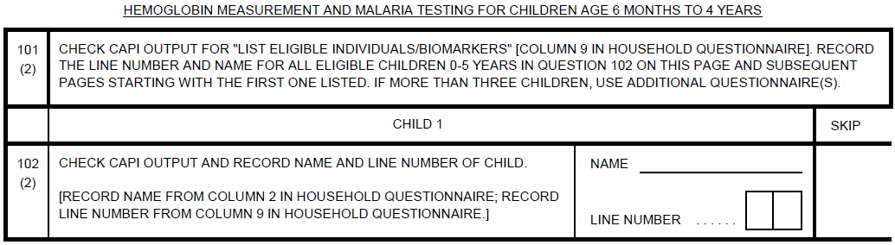

It is also your responsibility to fill in Qs. 103-106. If the child’s mother will be interviewed, the information needed for Qs. 103 and 104 will be updated in the CAPI list of eligible individuals after the mother’s interview with the Woman’s Questionnaire is complete. This step will be straightforward if the interviewer who interviewed the household also interviewed the child’s mother; just rerun the list of eligible individuals and biomarkers (which will now include the date of birth and age information from the pregnancy history) and finish filling out Q. 103-106 for each child. Otherwise, the household interviewer will need to coordinate with whichever team member interviewed the child’s mother to obtain this information; ask her to run the list of eligible individuals and biomarkers and then you will copy the age and date of birth information into Q. 103 and Q. 104. If the mother of the child is not interviewed or not available, the interviewer will need to ask a responsible adult Q. 103 and Q. 104. As will be discussed in Section 1 of the Woman’s Questionnaire, you will need to compare and correct Q. 103 and Q. 104 if the information provided by the respondent is inconsistent.

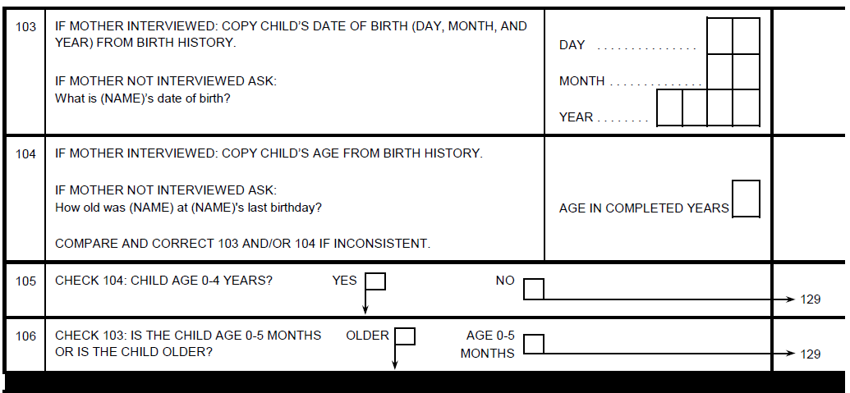

In Q. 105, if the child is age 0-4, put an X in the box next to YES and proceed to Q. 106. If the child is age 5 or older, put an X in the box next to NO, so the biomarker technician will know to skip to Q. 129 for that child.

In Q. 106, if the child is 6 months of age or older, put an X in the box next to OLDER. If the child is age 0-5 months, put an X in the box next to AGE 0-5 MONTHS, so the biomarker technician will know to skip to Q. 129 for that child.

In Q. 105, a child who is age 5 or older is not eligible for biomarker collection even though the child was identified in the Household Questionnaire as being eligible for the Biomarker Questionnaire (age 0-5). Why, you might be thinking, do we include children in the Biomarker Questionnaire Qs. 102-105, if we know from the Household Questionnaire that they are too old (age 5) to qualify for biomarker collection? Often respondents to the Household Questionnaire are uncertain of the exact age of children in the household and/or they round up a child’s age. So, for example, the respondent to the Household Questionnaire might say a child is age 5 when in fact the child is age 4, and therefore eligible for biomarker collection. The DHS Program has made the decision that we will not rely on the information from the Household Questionnaire for the exact age of children. Instead, we will get this information from the mother’s birth history (for children whose mothers are interviewed) or by asking an adult responsible for the child for the child’s date of birth and age information (for children whose mothers are not interviewed). This will help us be sure that we don’t miss out on any eligible children. Similarly, if we learn from the mother’s birth history that a child who was listed as age 6 in the Household Questionnaire is actually age 4, this child is eligible for biomarker collection. In such an instance, the child’s age should be corrected in the Household Questionnaire, and the list of eligible individuals and biomarkers should be rerun. The child will now be identified as eligible for biomarker collection and his or her information should be entered into the Biomarker Questionnaire.

You will notice a thick black line after Q. 106. This is to mark where your work is done, and the biomarker technician’s work starts. You will not fill in anything after Q. 106 for each child; Q. 107 and onwards are for the biomarker technician to fill out.

The Biomarker Questionnaire provides space for up to three children. If a household has more children eligible for the Biomarker Questionnaire than this, you will need to use an additional questionnaire: fill in the identification box and information on the number of eligible children and write “CONTINUATION” on the cover page. Inside, replace the section labels Child 1 with Child 4, Child 2 with Child 5, Child 3 with Child 6, etc., as necessary.

Interviewer’s checklist for Biomarker Questionnaire preparation:

- Front cover – Identification box at top
- Front cover – number of eligible children on right hand side
- Page 2 – Qs. 101-106 for Child 1
- [Page 5] – Qs. 101-106 for Child 2
- [Page 8] – Qs. 101-106 for Child 3

Once the biomarker technician has completed work in the household, he or she will return the Biomarker Questionnaire to [you or your supervisor] for entry into CAPI. [If it is returned to you, from your main menu, select the appropriate option (Enter Biomarker Data), and then select the appropriate household. Enter the data from the Biomarker Questionnaire, making sure to enter each child in the same order as in the questionnaire. If there are inconsistencies or skip errors, discuss with the biomarker technician.]

VI. WOMAN’S QUESTIONNAIRE
The Woman’s Questionnaire consists of a cover page and 4 sections as follows:

Section 1: Respondent’s Background
Section 2: Reproduction
Section 3: Pregnancy and Intermittent Preventive Treatment
Section 4: Fever in Children

The questionnaire also includes a page for interviewers to record observations and comments about the interview.

A. Cover Page

The overall layout of the cover page of the Woman’s Questionnaire is similar to the cover page of the Household Questionnaire except that the identification section includes the name and household line number of the woman eligible for interview. The CAPI system will automatically record the date of each visit you make and will prompt you to enter the result code of each visit.

B. Section 1: Respondent’s Background

In the first section of the questionnaire, you will begin by obtaining the respondent’s consent to the interview and then collect some general background information on the respondent.

INFORMED CONSENT

You must seek the respondent’s consent for participation in the survey. Read the informed consent statement exactly as it is written. This statement explains the purpose of the survey. It assures the respondent that her participation in the survey is completely voluntary and that she can refuse to answer any questions or stop the interview at any point.

After reading the statement, you must affirm that you have read the statement to the respondent. In a paper questionnaire, you do this by signing in the space provided. In a CAPI survey, you do this by selecting ‘1’ (RESPONDENT AGREES TO BE INTERVIEWED).

If the woman does not agree to be interviewed, select ‘2’, thank the respondent, and end the interview. Then select ‘4’ (REFUSED) as the result on the cover page.

REQUEST FOR DOCUMENTS

Before you begin the individual interview, ask the respondent to collect any birth certificates, identity cards, health/vaccination cards or other vaccination documentation, and other health records that she has for herself and her children. To complete some sections of the questionnaire, you will need to examine these documents, so assure the respondent that you have plenty of time to wait while she looks for them.

Q. 101: TIME

The time of the day you start the woman’s interview will be automatically recorded by the CAPI system.

Q. 102: MONTH AND YEAR OF BIRTH

Qs. 102 and 103 must be asked independently of the information on the Household Questionnaire. Even if you already asked the respondent her age when you were completing the Household Questionnaire, you must ask again for her date of birth on the Woman’s Questionnaire.

If the respondent knows her date of birth, write it in the appropriate boxes for MONTH and YEAR. You will need to convert the month into numbers. For this, January is ‘01,’ February is ‘02,’ March is ‘03,’ and so on. If she does not know her month of birth, select ‘98’ for DON’T KNOW MONTH and ask her for the year of her birth. If she knows the year, write it in the boxes for YEAR. Try under all circumstances to obtain at least the year of birth.

If the respondent is unable to provide this information, ask whether she has any documentation such as an identification card or a birth or baptismal certificate that might give her date of birth. Select ‘9998’ for DON’T KNOW YEAR only if the respondent does not know and cannot provide any record showing her birth date.

Q. 103: AGE

This is one of the most important questions in the interview, since almost all analysis of the survey data depends on the respondent’s age. You must ask Q. 103 even if the woman provided her birth date in response to Q. 102.

If the woman knows her age, enter it in the space provided.

If the woman does not know her age, you will need to use one of the following methods to estimate her age.

(a) If the year of birth is reported in Q. 102, compute the woman’s age as follows:

• Already celebrated birthday in the current year. If the woman has had her birthday in the current year, subtract the year of birth from the current year [2020].
• Not yet celebrated birthday in the current year. If the woman has not yet had her birthday in the current year, subtract the year of birth from last year [2019].
• Does not know when her birthday is. If the woman does not keep track of the time within a year when her birthday falls, it is sufficient to subtract year of birth from the current year [2020].

Tell the respondent the age you computed as she should know this information about herself. If she does not believe that the age you computed is her correct age, confirm that the year of birth she provided is correct.

(b) If the woman does not know her age, and the year of birth is not reported in Q. 102, you will have to probe to try to estimate her age. There are several ways to probe for age:

1) Ask the respondent how old she was when she got married or had her first child, and then try to estimate how long ago she got married or had her first child.

Example: If she says she was 19 years old when she had her first child and that the child is now 12 years old, she is probably 31 years old.

2) Relate her age to that of someone else in the household whose age is more reliably known.

3) Try to determine how old she was at the time of an important event such as a war, flood, earthquake, change in political regime, etc. and add her age at that time to the number of years that have passed since the event.

(c) The woman does not know her age and probing did not help.

If probing does not help in determining the respondent’s age and date of birth was not recorded in Q. 102, you will have to estimate her age. Remember, this is a last resort to be used only when all your efforts at probing have failed.

Checking Consistency of Birth Date and Age Responses

If the woman provides both her birth date and her age in Qs. 102 and 103, the CAPI program will alert you if the responses are inconsistent. The program, however, will not tell you which piece(s) of information (her birth date, her age, or both her birth date and age) are incorrect.

To understand the situations when the CAPI program will alert you that the responses are inconsistent, it is helpful to practice performing the consistency check manually. There are two methods for checking whether the age and year of birth are consistent: the arithmetic method and the chart method. A detailed description of each method follows. You may use either method to check the consistency of birth date and age information.

Arithmetic Method

The arithmetic procedure requires that you first calculate the sum of the year of birth and the age. Apply one of the following rules to determine if these responses are consistent.

(1) IF BOTH MONTH AND YEAR ARE RECORDED IN Q. 102:

• If the month of birth is before the month of interview (the respondent has had her birthday this year), then her age plus the year of birth should equal the year of interview [2020].

Example: A respondent that you interview in July [2020] tells you that she was born in January [1974] and is 46 years old. Her responses are consistent, i.e., her month of birth (January) is before the month of interview (July) and the year of birth [(1974)] and age (46) sum to the year of interview [(2020)].

Another respondent that you interview in July [2020] says she was born in May [1996] and she is 23 years old. Her responses are inconsistent, i.e., her year of birth [(1996)] and age (23) sum to [2019] rather than to [2020] as would be expected given that her month of birth (May) is before the month of interview (July).

• If the month of birth is after the month of interview (she has not had her birthday this year), then her age plus her year of birth should equal the previous year [2019].

Example: A respondent interviewed in July [2020] tells you that she was born in December [1987] and is 32 years old. Her responses are consistent, i.e., her month of birth (December) is after the month of interview (July) and the year of birth (1987) and age (32) sum to the previous year [(2019)].

Another respondent interviewed in July [2020] says that she was born in September [1982] and is 38 years old. Her responses are inconsistent, i.e., her year of birth [(1982)] and age (38) sum to [2020] rather than to [2019] as would be expected given that her birth month (September) is after the month of interview (July).

• If the month of birth is the same as the month of interview, then a sum of either [2019] or [2020] is acceptable.

(2) IF ONLY YEAR OF BIRTH IS RECORDED IN Q. 102:

Add the year of birth to the respondent’s age. Accept the sum if it is equal either to the year of interview [2020] or the previous year [2019].

Example: A respondent tells you she was born in [1990] and is 30 years old. Her answers are consistent since the sum of her year of birth ([1990]) and her age (30) is [2020].

Another respondent tells you she was born in [1990] and her age is 29 years. Her responses are consistent since the sum of the year of birth ([1990]) and her age (29) is [2019].

A third respondent tells you that she was born in [1990] and is 31 years old. Her responses are inconsistent since the sum of her year of birth [(1990)] and her age (31) is [2021].

Chart Method

You may use the Age/Birth-Date Consistency Chart (Figure 1) to check the consistency of the information the respondent provides. In using the chart, you will choose one of two approaches, depending on the type of information you have recorded in Q. 102.

(1) IF BOTH MONTH AND YEAR ARE RECORDED IN Q. 102:

Enter the chart at the age you recorded in Q. 103. If the month of birth is before the month of interview (she has already had her birthday this year), use the right-hand column to see what year of birth is consistent with that age. If the month of birth is after the month of interview (she has not yet had her birthday this year), use the left-hand column to see what year of birth is consistent with that age.

If the year of birth recorded in Q. 102 is not the same as the year of birth in the chart, then Qs. 102 and 103 are inconsistent and you will have to make a correction.

(2) IF ONLY YEAR OF BIRTH IS RECORDED IN Q. 102:

Enter the chart at the age you recorded in Q. 103. The year of birth listed in either the left-or right-hand column is consistent with that age.

If the year of birth recorded in Q. 102 is not the same as one of the two years of birth recorded in the chart, then Qs. 102 and 103 are inconsistent and you will have to make a correction.

FIGURE 1. AGE/BIRTH-DATE CONSISTENCY CHART FOR SURVEY IN 2020

Current  Age | Year of birth |  |  | Current  Age | Year of birth
 | Has not had birthday in 2020 | Has already had birthday in 2020 |  |  | Has not had birthday in 2020 | Has already had birthday in 2020
 | Don’t know |  |  |  | Don’t know
0 | 2019 |  |  | 30 | 1989 | 1990
1 | 2018 | 2019 |  | 31 | 1988 | 1989
2 | 2017 | 2018 |  | 32 | 1987 | 1988
3 | 2016 | 2017 |  | 33 | 1986 | 1987
4 | 2015 | 2016 |  | 34 | 1985 | 1986
5 | 2014 | 2015 |  | 35 | 1984 | 1985
6 | 2013 | 2014 |  | 36 | 1983 | 1984
7 | 2012 | 2013 |  | 37 | 1982 | 1983
8 | 2011 | 2012 |  | 38 | 1981 | 1982
9 | 2010 | 2011 |  | 39 | 1980 | 1981
10 | 2009 | 2010 |  | 40 | 1979 | 1980
11 | 2008 | 2009 |  | 41 | 1978 | 1979
12 | 2007 | 2008 |  | 42 | 1977 | 1978
13 | 2006 | 2007 |  | 43 | 1976 | 1977
14 | 2005 | 2006 |  | 44 | 1975 | 1976
15 | 2004 | 2005 |  | 45 | 1974 | 1975
16 | 2003 | 2004 |  | 46 | 1973 | 1974
17 | 2002 | 2003 |  | 47 | 1972 | 1973
18 | 2001 | 2002 |  | 48 | 1971 | 1972
19 | 2000 | 2001 |  | 49 | 1970 | 1971
20 | 1999 | 2000 |  | 50 | 1969 | 1970
21 | 1998 | 1999 |  | 51 | 1968 | 1969
22 | 1997 | 1998 |  | 52 | 1967 | 1968
23 | 1996 | 1997 |  | 53 | 1966 | 1967
24 | 1995 | 1996 |  | 54 | 1965 | 1966
25 | 1994 | 1995 |  | 55 | 1964 | 1965
26 | 1993 | 1994 |  | 56 | 1963 | 1964
27 | 1992 | 1993 |  | 57 | 1962 | 1963
28 | 1991 | 1992 |  | 58 | 1961 | 1962
29 | 1990 | 1991 |  | 59 | 1960 | 1961

[Note: A new chart must be constructed for surveys in 2021 or later.]

HOW TO CORRECT INCONSISTENT ANSWERS

If the recorded birth date (Q. 102) does not agree with the age (Q. 103), you must correct the inconsistency. Do this by further probing and adjusting the age, the birth date, or both. It is important to understand that either or both of the two pieces of information may be incorrect. Do not always assume that an inconsistency means, for instance, that the date of birth was given correctly and that the age is incorrect. It could be that the date or the age or both the date and the age are incorrect.

Remember, you MUST fill in an answer to Q. 103.

Finally, before moving on to the next question, verify that the respondent is indeed eligible. If the woman is younger than 15 years or 50 years or older you have to terminate the interview. Do this tactfully by asking two or three more questions, thank the respondent for her cooperation, and then discontinue the interview.

When you discover a respondent is outside the age group eligible for interview, you must correct the age and eligibility information for this woman in Columns (7) and (8) on the Household Questionnaire. In CAPI, doing so will automatically update the total number of eligible women reported on the cover page of the Household Questionnaire and in the assignment file.

Note that you should correct the information on the woman’s age in the Household Questionnaire only when it affects her eligibility status. Otherwise, do not change the age response in the Household Questionnaire.

Q. 104: EVER ATTENDED SCHOOL

The term “school” means formal schooling, which includes primary, secondary, and post-secondary school, and any other intermediate levels of schooling in the formal school system. It includes technical or vocational training beyond the primary-school level, such as long-term courses in computer software or trades such as mechanics, plumbing, or electrical work. However, this definition of school does not include preschool, Bible school or Koranic school, or short courses like typing or sewing.

If a respondent says she attended an early childhood education program, but not school, record NO for Q. 104 since for this question we are only interested in schooling received during childhood, adolescence, and adulthood but not early childhood.

Q. 105: HIGHEST LEVEL ATTENDED

Record the highest level the respondent ever attended, regardless of whether or not the year was completed. For example, if she attended secondary school for only two weeks, record SECONDARY.

Q. 106: HIGHEST [GRADE/FORM/YEAR] COMPLETED

For this question, record only the highest [grade/form/year] that the respondent successfully completed at that level.

Example: If a woman was attending [Grade 3] of [secondary school] and left school before completing that year, record [‘02’]. Although [Grade 3] was the highest year she attended, she completed only two years of [secondary school].

Example: If a woman attended only two weeks of [Grade 1] of [secondary school], record ‘00’ for completed years since she did not complete any [grades] at the [secondary school] level.

Q. 107: FILTER FOR EDUCATION LEVEL

Q. 108: LITERACY

Based on your knowledge of the respondent, choose the card with the language in which the respondent is likely to be able to read if she is literate. Show the first sentence on the card to the respondent. Give the respondent enough time to read the sentence; do not rush her. Record whether the respondent was not able to read the sentence at all, was able to read only parts of the sentence, or was able to read the whole sentence. If the respondent asks for a sentence in another language and you were provided a card with sentences in that language, show the respondent the appropriate card. If there is no card with sentences in the language required, select ‘4’ and specify the language.

It is important to avoid the problem of having other respondents in the household overhear the sentence being read. Subsequent respondents in the household might be able to repeat the sentence when they are interviewed, even if they are unable to read. If there is a second eligible respondent in the household, show her the second sentence on the card. Show the third respondent the third sentence on the card, and the fourth respondent the fourth sentence. If there are more than four respondents, start again with the first sentence on the card.

Q. 109: FILTER FOR LITERACY LEVEL

Q. 110: NEWSPAPER/MAGAZINE READING

The purpose of this question is to find out whether the respondent is exposed to influences outside her local community by reading newspapers or magazines. It does not matter what type of articles she reads, what language she reads in, or who buys the newspapers or magazines she reads. The question is simply about how often she reads them. Make sure that you read the entire question before accepting her answer.

If the respondent tells you that she is reading newspapers or magazines on the Internet, this should still be considered as exposure. The objective is to collect information on whether respondents are accessing newspapers or magazines, and if so, how frequently.

Q. 111: RADIO LISTENING

The purpose of this question is to establish whether the respondent is exposed to radio programming, by whatever means. Accessing the radio through the Internet or cable services, or other means is also included here. If there is any doubt as to whether the respondent listens to the radio at least once a week, probe. For example, after probing, if she says “I listen almost every day, but during the planting season, I’m away and I don’t listen at all,” record “at least once a week,” since she normally listens almost every day. It does not matter who owns the radio or what program she listens to. Again, make sure to read the entire question.

Q. 112: TELEVISION WATCHING

As with Qs. 110 and 111, the purpose is to get an idea of how much exposure the respondent has to influences outside her place of residence, this time through television broadcasts. It does not matter who owns the television or what program she watches.

A respondent watching television broadcasts via the Internet on a computer, smart phone, or other means should still be considered as watching television, as long as she is accessing television broadcasts.

Qs. 113 and 114: MOBILE PHONE OWNERSHIP

In Q. 113, ask the respondent if she owns a mobile phone. If the respondent says she has access to a mobile phone, but the phone does not belong to her, record NO and skip to Q. 115. If she says she owns a mobile telephone jointly with someone else, record YES.

In Q. 114, ask the respondent if the mobile phone she owns is a smart phone. A smart phone is a mobile phone that performs many of the functions of a computer, typically having a touchscreen surface, Internet access, and an operating system capable of running software applications (“apps”).

Qs. 115-117: INTERNET USE

The Internet is a world-wide public computer network. Internet use includes accessing web pages, e-mail, instant messaging, applications (such as WhatsApp), and social media (such as Facebook, Twitter, and Instagram). Internet access can be via a fixed or mobile network, and can occur via desktop, laptop, and tablet computers, smart phones, and other devices such as e-readers, smart televisions, and game machines. These questions ask about ever use, use in the last 12 months, and frequency of use in the last month. The type of device used to access the Internet does not matter. It also does not matter if the Internet use takes place in the household where the respondent is living or elsewhere.

Qs. 118 and 119: RELIGION AND ETHNICITY

Ask the respondent for her religion in Q. 118 and her ethnic group in Q. 119. If she belongs to a religion or ethnic group not listed, select ‘96’ for OTHER and write in her response. If the respondent belongs to more than one ethnic group, probe to find out her main ethnic group and record her response accordingly.

C. Section 2: Reproduction

In this section, information is collected about the births that a woman has had during her life, additional information on births she had between [2015] and [2020], and her current pregnancy status. This is a particularly important section, and you need to be especially careful to obtain all the required information.

GENERAL NOTES ABOUT Qs. 201-209

This group of questions collects information about all births that the woman has had (no matter who the father is). It is important that you understand which events to include. We want to record all of the respondent’s natural births. You should record all children who were born alive (that is, who showed signs of life by crying, breathing, or moving) even if they survived only for a few minutes. We want to know about all the woman’s births even if the child no longer stays in the household or if the child is no longer alive.

It is also important to understand which events should not be recorded. You must not record adopted or foster children or children of relatives who may be living in the household. You also should not include any of her husband’s children to whom the respondent did not give birth herself. Finally, you must not record children who were born dead (stillbirths) or miscarriages or abortions.

Q. 201: EVER GIVEN BIRTH

This question serves two purposes: to introduce the section and to learn whether the respondent has ever given birth. Even if the woman tells you that she never gave birth (Q. 201 is NO), you must go on to ask Q. 206 since she may not have told you about children who died very young.

Q. 202: ANY CHILDREN LIVING WITH HER

Read the question slowly. The sons and daughters being considered are her OWN natural (biological) children who live with her in her household (which will usually be the household in which the interview is being held, except for women who are visitors).
Q. 203: NUMBER OF CHILDREN LIVING WITH HER

Fill in the number of sons and daughters who live with the respondent. If she has only sons living with her, enter ‘00’ in the boxes for daughters, and vice versa. Remember that we are only interested in the respondent’s OWN natural (biological) children and not foster children, children of her husband by another woman, or children of a relative.

Note that it is never correct to record ‘00’ in the boxes for both sons and daughters since women who have no children living at home skip directly from Q. 202 to Q. 204.

Qs. 204 and 205: ANY CHILDREN LIVING ELSEWHERE

These questions refer to the respondent’s sons and daughters who are alive but not living with her. For example, they may be living with a relative, may be staying at a boarding school, may have been given up for adoption, or may be grown-up children who have left home. If she has only sons living elsewhere, enter ‘00’ in the boxes in Q. 205 for daughters, and vice versa. Make sure the respondent is not reporting dead children in this question.

Qs. 206 and 207: CHILDREN WHO DIED

These questions on children who have died are extremely important and are among the most difficult on which to obtain accurate data. Some respondents may fail to mention children who died very young, so if a woman answers NO, it is important to probe by asking, “Any baby who cried, who made any movement, sound, or effort to breathe, or who showed any other signs of life even if for a very short time?” Some respondents may be reluctant to talk about this subject and may become sad or upset that you are asking such questions. Be sympathetic and tactful in such situations. Say that you know the subject is painful but that the information is important.

Q. 208: TOTAL LIVE BIRTHS

The CAPI program will add up the numbers in Qs. 203, 205, and 207 and enter the total in Q. 208.

Q. 209: CHECKING TOTAL WITH RESPONDENT

Ask the respondent whether the total entered in Q. 208 is correct. If she says NO, select NO, and return to Qs. 201-208 to check with the respondent whether you have obtained the information correctly.

Example: Starting with Q. 203, you would ask, “You have two sons and one daughter living with you. Is that correct?” Do the same for Qs. 205 and 207. If you have made any changes to Qs. 203, 205, and 207, a new total will be entered in Qs. 208 and 209.

Once you have made sure the total number of births is correct, change the code in Q. 209 from NO to YES and proceed with Q. 210.

Q. 210: FILTER FOR NUMBER OF BIRTHS

Q. 211: NUMBER OF BIRTHS IN [2015-2020]

In Q. 211, ask the woman how many of her children have been born in [2015-2020]. Write the number of births in [2015-2020] in the box. If she has not had any births in [2015-2020], choose ‘00’ and skip to Q. 224.
Qs. 212-221: PARTIAL BIRTH HISTORY TABLE

In the birth history table, we want a complete list of all the live births the respondent has had in the years [2015-2020] starting with her most recent birth. Each birth/child will occupy one row in the birth history table.

Q. 212: REQUEST FOR BIRTH HISTORY

Begin the section by informing the respondent that we would like to record all of her children born in [2015-2020], from all marriages and unions, whether or not they are still alive. The only births we will not include are stillbirths.

For each birth, you will ask Qs. 213-215 in one row (the end of which is marked by a thick black line), before moving to the next birth in the next row. After all the births are listed and the information in Qs. 213-215 has been entered for each, you will then complete Qs. 216-221 for each birth.

Q. 213: CHILD’S NAME

Record the name of each child that the respondent mentions on a separate line in Q. 213, beginning with the most recent birth. If the woman reports that she had a multiple birth (twins, triplets, etc.), record each of the children on a separate line.

Write the name that distinguishes that child from the others—in other words, if there are two children, Harvey Johnson and Matilda Johnson, write “Harvey Johnson” and “Matilda J.,” not “H. Johnson” and “M. Johnson.” If the baby never had a name, either because it is still very young or because it died when it was very young, write “Baby” for the name.

Q. 214: CHILD’S SEX

Select the code for the sex of the child. Although you can often tell the sex from the name, check with the respondent by saying, for example, “and Joyce is a girl?” Do not assume the sex of the child from the name.

Q. 215: SINGLE OR MULTIPLE PREGNANCIES

Record the status of each child (SINGLE or MULTIPLE birth) in Q. 215.

For example, a respondent’s most recent pregnancy resulted in twin boys, Marcus (born first) and Michael (born second). The birth prior to the twins was a single child (Esther). In Q. 215, code 2 (MULT) would be entered in line 01 (Michael) and line 02 (Marcus). Code 1 (SING) would be entered in line 03 (Esther). Michael is recorded on line 01 because as the second born twin, he is the most recent birth.

Note that there is also a thick vertical line separating Q. 215 from Qs. 216. It is meant to remind you to complete Q. 213-215 for all of the respondent’s births, before proceeding to ask Qs. 216-221 for each birth. In other words, only after you have completed Qs. 213-215 for all births, are you ready to proceed with Qs. 216-221 beginning with the most recent birth. Ask all the questions for one child before going on to the next child.

Q. 216: DAY, MONTH, AND YEAR OF BIRTH

When collecting information on a child’s birth date, always look at any documents you collected from the woman at the beginning of the interview (e.g., birth certificate, child’s immunization record, or mother’s health documents) to see whether a date of birth was recorded. Before entering a date from these documents, however, check with the respondent to determine whether she believes the date is accurate. In some cases, the information on the document may be the date when the event was recorded and not the date when the child was born.

If the respondent gives you a year of birth but does not know the day or month of birth, probe to get an estimate of the day and month.

Example: if a respondent says her daughter was born in 2019, but she does not know which day or month, ask her whether she gave birth in the dry or wet season, whether she remembers if she was pregnant [during Ramadan or at Christmas or Easter time], or during some other significant event/season of the year to try to determine at least the month of birth. Convert months to numbers, as before. If you have no information on the day of birth, write ‘98’ for DAY. If you cannot estimate a month, write ‘98’ for MONTH. You must provide a year of birth.

If the respondent cannot recall the year when the birth occurred, you need to probe carefully. See if the respondent knows a firm birth date for any other child in the household and relate it to that.

Example: If she knows the second child was born in 2020 and the first child was just a year old at that time, enter ‘2019’.

You must enter a year for all births, even if it is just the respondent’s best estimate. Because we are only asking about births that occurred in [2015-2020], you must make every effort to enter both a month and year of birth, even if it is an estimate.

Q. 217: CHILD’S SURVIVAL STATUS

In Q. 217, we are asking the respondent whether a child that was born alive is still alive or not. If the child was born alive but died later on, select ‘2’ NO and skip to Q. 221.

Q. 218: AGE OF LIVING CHILD

The age of all living children should be recorded in completed years.

Example: A child who will become three years old next month should be recorded as ‘02’ years today. A child less than one year old will be recorded as age ‘00’ years.

Sometimes, a mother will not know the current age of her child. In this case, you may rephrase the question to, “How many years ago was John born?” You can also use other available information such as relating John’s age to the age of a child she does know.

Example: The mother may know that her youngest child was born one year ago and that John was around two years old at that time, in which case John would be three years old now.

You MUST record an age for all children who are still alive.

CONSISTENCY CHECK: DATE OF BIRTH AND AGE

You are not finished with Q. 218 until the consistency between Q. 216 (date of birth) and Q. 218 (age) has been checked. The CAPI program will automatically alert you if the answers to Q. 216 and Q. 218 are inconsistent. To do this check manually, you would use either the arithmetic or chart procedure:

Arithmetic procedure. Add the year of birth and the age. If the child has already had a birthday this year (month of birth is prior to month of interview, or month of birth is the same as the month of interview and day of birth is on or before the day of interview), the sum should be [2020]. If the child has not had a birthday yet this year (month of birth is after month of interview, or month of birth is the same as the month of interview and day of birth is after the day of interview), the sum should be [2019]. If the child’s month of birth is the same as the month of interview and the day of birth is not known, the sum can be either [2019] or [2020]. If the month of birth is not known, the sum can be either [2019] or [2020].

Age/Birth Date Consistency Chart. Locate the age on the chart (Figure 1). Check that the birth year is consistent with that age in the chart. Use the right-hand column if the month of birth is before the month of interview and the left-hand column if the month of birth is after the month of interview. If the month of birth is the same as the month of interview, use the right-hand column if the day of birth is on or before the day of interview and the left-hand column if the day of birth is after the day of interview. If the month of birth is not known, or the month of birth is the same as the month of interview and the day of birth is not known, the year of birth must be the same as one of the two years of birth recorded in the chart.

Both these procedures are explained in more detail after Qs. 102 and 103.

If year of birth date and age are not consistent, probe to get the correct information. Remember when probing, that either or both responses—age or birth date—may be wrong.

Q. 219: CHILD LIVING WITH MOTHER

This question is important in determining the extent to which children live away from their natural (biological) mothers. If a child is away at boarding school or lives with other people on a permanent basis, record NO. If the child is away for a short while but usually lives with the mother, record YES.

Q. 220: HOUSEHOLD LINE NUMBER OF CHILD

In Q. 220, record the line number of the child from Column 1 of the Household Schedule in the Household Questionnaire. If the child is not living in the household, enter ‘00’ in the boxes. If the child is not listed in the Household Schedule, but the mother says that the child is in fact a usual resident or a visitor in the household, you will need to add the child to the Household Schedule.

Be careful in recording the line number from the Household Schedule since any errors will cause problems during data processing.

After completing Q. 220 for the most recent birth, proceed to Q. 216 for the preceding birth.

Q. 221: PROBING THE INTERVAL BETWEEN BIRTHS

The purpose of this question is to make sure that we have not missed any of the respondent’s BIRTHS. For all births except the most recent (the first row), you must ask the respondent whether there were any live births between the previous birth and the birth you have been discussing. If the woman tells you there was no other birth, record NO in Q. 221.

If the woman tells you that there was another birth, record YES in Q. 221. You will then need to add the additional birth to the table and ask Qs. 213-221.

Example: Initially a respondent tells you that she has had three births in [2015-2020], the most recent a child named Michael, preceded by Mary, who was preceded by David. After recording all of the information for Qs. 213-220 for David as appropriate, you ask Q. 221: “Were there any other live births between David and Mary?” The woman tells you there was a child born after Mary and before David. Record YES in Q. 221. You will then add the missing child to the birth history.

In a paper questionnaire, you would add the missing child to the end of the birth history table, draw an arrow to show the location of the missing child between Mary and David, and renumber the birth history numbers to reflect the correct order of the births. The method you will use to add a birth to the birth history table in the CAPI system will be discussed during the CAPI training.

OTHER POINTS ABOUT THE BIRTH HISTORY TABLE

1) Recording of year of birth and age of living children. For day of the birth in Q. 216, it is permissible to record Code ‘98’ for DON’T KNOW as an answer. For month of the birth in Q. 216, it is possible to record Code ‘98’ for DON’T KNOW, but this code should only be used when it is not possible to come up with an estimate. However, for year of birth (Q. 216) and age of living children (Q. 218), you must record an answer. It is very important to obtain information for these questions, so you must probe for this information and, if necessary, work with the respondent to obtain a best estimate on the basis of the woman’s answers.

2) Recording of information on twins (or triplets, etc.). If there are any twins, record the information about each twin on a separate line. If the twins are the respondent’s last birth and if one twin is dead, record the living twin first. By doing this, you will be able to talk about the living twin when you get to Section 3, which may be more comforting for the respondent.

3) Checking birth interval. Check the dates of each birth. If any two children are reported born less than seven months apart, e.g., December 2018 and May 2019, probe and correct the dates. Either the December birth occurred earlier or the May birth occurred later, or both.

Q. 222: PROBING THE INTERVAL SINCE LAST BIRTH

This question is similar to Q. 221 but is specifically designed to probe the time that has passed since the most recent birth.

Example: If Elizabeth is a respondent’s most recent birth, and she was born in [2019], ask, “Have you had any live births since the birth of Elizabeth?”

If there was no birth after Elizabeth, record NO in Q. 222. If the woman tells you there was a birth since Elizabeth, record YES in Q. 222 and add that birth to the birth history (and renumber the births that are in the history accordingly). Then ask Qs. 213-221 for that birth. You may also have to correct the information in Qs. 202-211.

Q. 223: CONSISTENCY OF TOTAL BIRTHS

The CAPI program will compare the number of births in Q. 211 to the number of births listed in the birth history table. If the number in the table is equal to the number in Q. 211, you will proceed to Q. 224.

If the number in the birth history is different from the number recorded in Q. 211, you must probe to find the cause of the difference and correct it before you continue to Q. 224. This may necessitate adding births to the birth history table or subtracting births from Qs. 203, 205, or 207. When properly completed, your questionnaire must always have the same or more births in the table as the number recorded in Q. 211.

Q. 224: CURRENT PREGNANCY STATUS

Q. 225: WEEKS OR MONTHS OF CURRENT PREGNANCY

Record the answer in completed weeks or months, putting a zero in the first box if she has completed nine or fewer weeks or months of pregnancy. You may need to check that the woman is responding in completed weeks or months.

Example: If the woman answers that she is ‘five months pregnant,’ ask “Are you in your fifth month of pregnancy, or have you completed your fifth month of pregnancy?” Record ‘04’ if she responds that she is in the fifth month of pregnancy and ‘05’ if she has completed five months of pregnancy.

If the woman does not know how many weeks or months she has been pregnant, probe to get an estimate by asking, for example, about the date of her last menstrual period.

D. Section 3: Pregnancy and Intermittent Preventive Treatment

During pregnancy, a woman’s immune system is weakened, making her more susceptible to malaria, as compared with women who are not pregnant. Malaria in pregnant women can cause several complications that are dangerous to the mother and unborn child, including severe malaria and death, maternal anemia, and low birth weight of the newborn. The World Health Organization recommends that pregnant women in malaria endemic areas take a dose of SP/Fansidar (usually three tablets taken all at once), as a preventive measure, once a month, starting as early as possible in the second trimester of pregnancy. Preventive treatment with SP/Fansidar at least three times during pregnancy is known as intermittent preventive treatment in pregnant women (IPTp). The majority of women receive IPTp during antenatal care visits, however, IPTp can also be received as part of another health facility visit or from another source such as a community health worker. The generic name for SP/Fansidar is sulfadoxine-pyrimethamine, but there can be other brand names.

This section includes questions only about the most recent birth that occurred in the 35 months before the survey. Thus, if a woman did not have a birth in this period, you will go on to the next section.

Q. 301: FILTER FOR ONE OR MORE BIRTHS IN 0-35 MONTHS BEFORE SURVEY

Q. 302: MOST RECENT BIRTH IN 0-35 MONTHS BEFORE SURVEY

CAPI will automatically insert the name of the most recent birth in this section.

Q. 303: RESPONDENT SOUGHT ANTENATAL CARE

Introduce Section 3 of the questionnaire to the respondent by reading the statement and the question in Q. 303. This question refers to any antenatal care given by a healthcare provider during the pregnancy that resulted in her most recent birth. The care should have been specifically to check her pregnancy and not for other reasons.

Q. 304: ANTENATAL CARE PROVIDER(S)

If the respondent received antenatal care for her pregnancy in Q. 303, then ask her whom she saw. Since we are interested in all of the persons the woman saw, you must use the prompt (“Anyone else?”) to make sure the woman informs you about all the persons from whom she received care for the pregnancy.

Q. 305: PLACE(S) WHERE ANTENATAL CARE RECEIVED

This question seeks information on where the woman received care for her pregnancy. Antenatal care is usually given at a healthcare facility but is sometimes provided in the pregnant woman’s home.

Similar to Q. 304, we are interested in all of the places where the woman received antenatal care. Be sure to use the prompt (“Anywhere else?”) and record all the places where she was seen for care.

When choosing a code in Q. 305, you need to know whether the place is in the public sector (run by the government), in the private sector (e.g., a hospital or clinic run by a private entity or a private doctor’s office), or in the NGO medical sector. If you cannot determine the type(s) of source(s), select code ‘X’ and write the name(s) in the space provided.

Q. 306: WEEKS OR MONTHS PREGNANT AT FIRST ANTENATAL VISIT

Ask the respondent how many weeks or months into her pregnancy she was when she received her first antenatal care. If she does not remember, ask her how many periods she had missed at the time. Assume each missed period corresponds to a month and enter the number in the space provided. For example, if the respondent doesn’t recall how many months pregnant she was when she first received antenatal care, but knows that she had missed three periods, record ‘03’ in MONTHS.

Q. 307: FREQUENCY OF ANTENATAL VISITS

Then ask her how many times in total she saw someone for antenatal care during her pregnancy. This refers to care related to her pregnancy and should not include seeing a doctor or nurse for other reasons.

Q. 308: PREVENTIVE TREATMENT FOR MALARIA DURING PREGNANCY

In certain areas, malaria is endemic and accounts for a significant proportion of illness/disease and mortality. In such areas, pregnant women are recommended to take SP/Fansidar at least three times during their pregnancy to prevent malaria. To see if the respondent followed this precaution, we ask in Q. 308 if she took SP/Fansidar to prevent her from getting malaria during her pregnancy.

If the respondent says that she had malaria or a fever during the pregnancy and was given medicines to treat the malaria or fever, it would not be considered preventive treatment. Medicines to prevent malaria are only medicines that she takes during pregnancy when she does not have malaria already. Record YES only for women who took SP/Fansidar when they did not already have malaria.

If she says she took medicine but cannot remember the name, ask her to show you the package that the medicine came in. If she doesn’t have the package but mentions that she was given three tablets to take all at the same time to prevent malaria, select ‘1’ on the assumption that she took SP/Fansidar.

Q. 309: NUMBER OF TIMES SP/FANSIDAR WAS TAKEN

Here we are asking about preventive doses of SP/Fansidar, not curative doses given if the respondent had a fever. Thus, you should count only the doses taken when the woman was taking SP/Fansidar during her pregnancy to prevent malaria. If the woman was given SP/Fansidar because she was sick with fever during the pregnancy, do not count the doses she received to treat her fever.

Remember that we are interested in the number of times the woman took SP/Fansidar and not the number of tablets she took. Thus, if she says she took three tablets at one time, record ‘01’ for the dose in Q. 309.

Q. 310: SOURCE OF SP/FANSIDAR

The purpose of this question is to find out whether the respondent received SP/Fansidar as an integrated component of her antenatal care or separate from her antenatal care. For example, she could have gotten the SP/Fansidar during a non-ANC facility visit, or she could have bought it on her own from another source such as a shop or a pharmacy. Only one response code can be selected in this question. If the respondent got SP/Fansidar from two or more of the sources, select the source that appears highest on the list.

E. Section 4: Fever in Children

Section 4 is focused on all surviving children who are born in the 0-59 months before the survey. We are interested in learning about the incidence of fever in young children and how fever is treated. You will ask all the questions in Section 4 for the most recent surviving birth before moving to the next most recent surviving birth.

Q. 401: FILTER FOR SURVIVING CHILDREN AGE 0-59 MONTHS

Q. 402: INTRODUCTORY STATEMENT

Q. 403: CHILD’S NAME AND BIRTH HISTORY NUMBER

Qs. 404-406: FEVER IN LAST 2 WEEKS AND MALARIA

Fever is a common symptom of many conditions and diseases including malaria and pneumonia, which are two of the principal causes of death for young children in many countries. Often children with fever receive treatment for malaria regardless of whether they have malaria or pneumonia. As a result, antimalarial drug resistance has become a major problem. To stop it, healthcare providers must diagnose malaria in children, and provide treatment for malaria only to those children who are infected with malaria parasites. Malaria is diagnosed by taking a few drops of blood from the patient and examining them for the presence of malaria parasites or malaria-specific proteins.

For Q. 404 record YES only if the fever occurred in the 2 weeks prior to the date of interview and then go on to Q. 405 to ask whether blood was taken from the child’s finger or heel for testing. Note that the question asks only whether blood was taken, not specifically whether it was taken for a malaria test since the respondent may not know why the blood was taken.

Regardless of whether or not the child had their blood tested during the illness, ask Q. 406 to determine if a healthcare provider told the respondent that her child had malaria.

Qs. 407 and 408: ADVICE OR TREATMENT FOR FEVER SOUGHT

Record YES in Q. 407 if anyone sought advice or treatment for the child’s fever; somebody other than the respondent (for example, the grandmother) can have sought advice or treatment. If advice or treatment was sought, go on to ask Q. 408. Probe to determine whether more than one place or more than one person was consulted, and record all places mentioned.

Q. 409: FILTER FOR NUMBER OF PLACES FOR FEVER ADVICE OR TREATMENT

Q. 410: FIRST PLACE FOR FEVER ADVICE OR TREATMENT

For respondents naming more than one source in Q. 408, probe in Q. 410 for the first place where advice or treatment for the fever was sought. If the woman mentions a source that is not recorded in Q. 408, first probe to be sure that advice or treatment was sought from the source and then add that source in Q. 408.

Q. 411: TIME TO SEEK ADVICE OR TREATMENT

Record the number of days after the illness began that advice or treatment was first sought. If advice or treatment was sought the same day the illness began, record ‘00’.

Qs. 412 and 413: TREATMENT OF THE FEVER

Ask the respondent whether the child who had an illness with fever in the last 2 weeks has taken any medicine for the illness and, if so, what medicine the child received.

Note that more than one type of medicine may have been administered to the child during the illness, and you should record all the medicine mentioned by the respondent. If she does not know the name of the medicine(s), ask her to show you the medicine(s) and/or show her the showcards of antimalarials [in the CAPI system] to see if she recognizes the packaging. Record DON’T KNOW only if she cannot show you the medicine or you cannot determine the type of medicine given to the child.

When you ask Q. 413, the respondent may or may not give you an answer that fits neatly into the categories in the questionnaire.  Consider the guidance below and if you are in doubt as to how to classify a medicine, but the respondent is sure it was an antimalarial, select code I - ‘OTHER ANTIMALARIAL’ and record the brand and/or medicine names. For example, you may encounter antimalarials such as [Mefloquine, Lariam, Malarone or COUNTRY-SPECIFIC EXAMPLES] that do not belong in any of the other categories. | 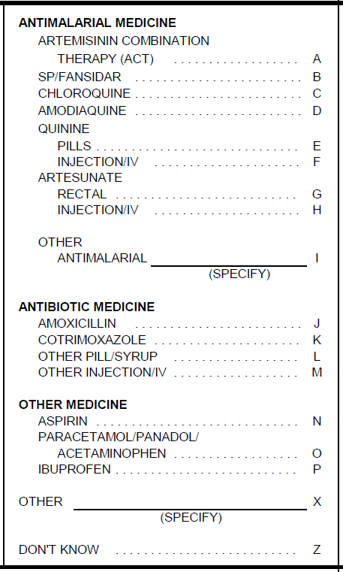

- Artemisinin-based Combination Therapy (ACT) refers to a class of medicines containing both an artemisinin-based compound and another medicine; ACTs are the recommended first line antimalarial treatment. Medicines containing just an artemisinin compound or just one of the ‘other’ medicines below are NOT ACTs and should not be recorded as such.

Artemisinin compound | + | Other medicine | = ACT
Dihydroartemisinin  or  Artesunate  or  Artemether  or  Artemisinin |  | Lumefantrine  or  Napthoquine  or  Mefloquine  or  Amodiaquine  or  Sulfadoxine/pyrimethamine  or  Piperaquine  or  Chlorproguanil/dapsone

Combination | Common brand names of ACTs in [COUNTRY]
Artemether + Lumefantrine
Artemisinin + Napthoquine
Dihydroartemisinin + Piperaquine
Artesunate + Amodiaquine
Artesunate + Mefloquine

- SP/Fansidar is a medicine containing sulfadoxine-pyrimethamine; it is most commonly known as SP or SP/Fansidar, but there can be other brand names such as [COUNTRY-SPECIFIC BRAND NAMES].

- Chloroquine has many brand names, including [COUNTRY-SPECIFIC BRAND NAMES].

- Amodiaquine (alone, not as part of an ACT) may be sold as Amodiaquine suspension, Amodiaquine hydrochloride, or [COUNTRY-SPECIFIC BRAND NAMES].

- Quinine may also be known as [COUNTRY-SPECIFIC BRAND NAMES].

- Artesunate (alone, not as part of an ACT) has many brand names, including [COUNTRY-SPECIFIC BRAND NAMES].

Q. 414: FILTER FOR ARTEMISININ-BASED COMBINATION THERAPY (‘A’) GIVEN

Q. 415: LENGTH OF TIME CHILD HAD FEVER BEFORE BEING TREATED WITH ARTEMISININ-BASED COMBINATION THERAPY

This question asks about the time interval between the beginning of the child’s fever and when he/she took the first dose of artemisinin-based combination therapy (ACT). If he/she started taking an ACT the same day the fever started, select ‘0’ for SAME DAY. If an ACT was first given the next day (the day after the fever began), select ‘1’ for NEXT DAY, and so on.

Q. 416: FILTER FOR ADDITIONAL SURVIVING CHILDREN BORN 0-59 MONTHS BEFORE THE SURVEY

Qs. 403-415 will be repeated for all additional surviving children age 0-59 months.

Q. 417: TIME INTERVIEW ENDED

The CAPI system will automatically record the time the interview was finished. If there was an extended break during the interview time (for example, the respondent excused herself to care for a sick child and returned to complete the interview 45 minutes later), make a note to report how long a break was taken in the Interviewer’s Observations section.

Be sure to thank the respondent for her cooperation. Also, inform the respondent that a biomarker technician will be coming to her household to ask consent to test young children for anemia and malaria. If she has any simple, general questions about the biomarker tests, you can answer them, but tell her that the biomarker technician will explain the tests in more detail and will answer her questions.

F. Interviewer’s Observations

After you have checked over your questionnaire and thanked the respondent, note any comments on the last page. You may make comments about the woman you interviewed, about specific questions on the questionnaire, or about any other aspects of the interview. If anything about the interview was unusual or should be brought to the attention of the supervisor, note it here. Even if the interview was straightforward, a few comments on each interview will be helpful in editing and processing the questionnaires. For example, if a respondent attended school in a different country, one with a different system for dividing grades into primary and secondary, note that here. If you were unable to complete the interview for any reason, or if answers that were not precoded require further explanation, use this space. All these comments are helpful to the supervisor and data processing staff in interpreting the information in the questionnaire.

END OF INTERVIEWER’S MANUAL

Text in brackets should be replaced with country-specific information or deleted as necessary.
Use country-specific term for biomarker technician such as nurse, health technician, health investigator, or biomarker specialist.
Fansidar is a brand name for the malaria medicine SP. There are also many other brand names for SP. If Fansidar is not a commonly known brand in the country, change "Fansidar" to the most commonly known brand name for SP, like this "SP/NEW BRAND NAME". Or you can simply delete "/Fansidar" and leave "SP" on its own.

